US Veterans’ Day: I took an oath to “…support and defend the Constitution of the United States of America against all enemies, foreign and domestic…”
James A. Waddell, 2nd Infantry Division, South Korea DMZ, 8th United States Army. 11/10/09
This was an oath to defend the Constitution of the United States of America. There are many elected USA officials and government civil servants who took a very similar oath to preserve, protect and defend the Constitution of the United States.
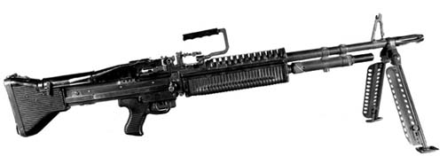
M-14 riflemen and soldiers with M-60 Machine guns were the “Grunts” of the Army Ground Forces of the USA. Without the weapons of protection, whether military or civilian, we would have a hard time defending our Nation’s Constitution, our families and our lives against armed enemies?

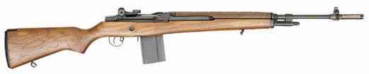
“You have won the Cold War.” From the Veterans of Foreign Wars Magazine by The Editors, November/December 2009: “Millions of Americans served in the Cold War between 1945 and 1991. Many were in overlooked campaigns, crises and confrontations and on forgotten fronts beyond the full-fledged wars in Korea and Vietnam.” I speak of the US soldiers who were in frozen foxholes or in jungle mud.
Here are some of those places where USA men and women fought and lived or fought and died for the citizens of those countries in what is known as the Cold War:
1 Philippines, 2 Taiwan, 3 Laos, 4 China, 5 South Korea, 6 North Korea, 7 Siberia, 8 New Siberian Islands, 9 Severnaya Zemlya, 10 Novaya Zemlya, 11 Svalbard, 12 Germany, 13 Czechoslovakia, 14 Armenia, 15 Turkey, 16 Hungary, 17 Lebanon, 18 Congo, 19 Angola, 20 Greece, 21 Albania, 22 Yugoslavia, 23 Austria, 24 Iceland, 25 Greenland, 26 Arctic Ocean, 27 North Atlantic Ocean, 28 Central Atlantic Ocean, 29 South Atlantic Ocean, 30 Cuba, 31 Dominican Republic, 32 Grenada, 33 El Salvador, 34 Nicaragua, 35 Bolivia, 36 Chile, 37 North Pacific Ocean, 38 Eastern Pacific Ocean, 39 Western Pacific Ocean, 40 South Pacific Ocean, and number 41 is to represent the many places that regular citizens never knew about!
Many of these countries received United States of America money as well as military help. Many are still receiving money from the working citizens of the United States! The Armed Forces and the secret operatives of the USA have kept enough land to provide for our military men and women and have plots of land for the graves of those soldiers, sailors, submariners and flyers that were killed or died in USA service to these countries.
I have hope that US Military Veterans and their families will never allow our Constitution of the United States of America to be taken over and lose the world’s most needed Protectors of Freedom!
JW
I reiterate: “Without the weapons of protection, whether military or civilian, we would have a hard time defending our Nation’s Constitution, our families and our lives against armed enemies?” Re: Woman cop stops the killing at Fort Hood!
That goes for ammo as well! “An empty gun is just another piece of steel!”

