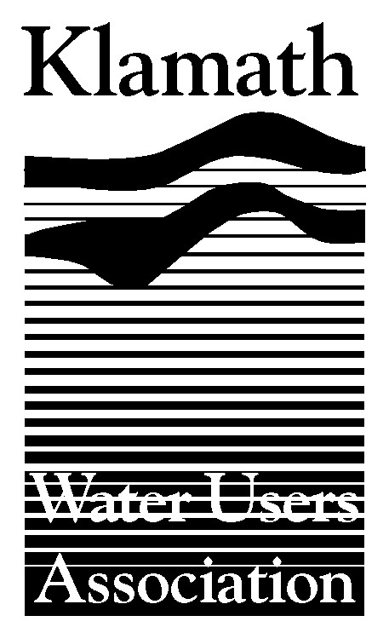
Klamath Water Users Association
2455 Patterson Street, Suite 3
Klamath Falls, Oregon 97603
(541)-883-6100 FAX (541)-883-8893
kwua@cvcwireless.net
www.kwua.org

Water Rights Settlements
Between Basin Tribes and Klamath Reclamation Project

Key Elements of the Proposed
Klamath Basin Restoration Agreement

January 29, 2008

Summary

The proposed Klamath Basin Restoration Agreement released on January 15, 2008, (KBRA) is structured to settle tribal water rights claims between tribes in the Klamath Basin and the Klamath Project. In essence, water users in the Klamath Project would agree to limit, to a specified amount, the quantity of water diverted from Upper Klamath Lake and the Klamath River from the Project’s points of diversion identified in Appendix E-1 of the KBRA. The KBRA also provides for funding of a program so that Project water users will be able to “live within” the agreed quantity. (Section 15.2 and Appendix B-2.) Tribes, and the United States as their trustee, would agree not to assert tribal rights so as to interfere with this agreed Klamath Project use of water, making it guaranteed as far as tribal water rights and trust obligations of the Bureau of Reclamation are concerned. In the Klamath Basin Water Rights Adjudication, where claims of the Klamath Tribes are scheduled to be litigated in the next few years, the KBRA terms would be implemented through documents filed with the state.

The KBRA would not result in granting any tribal water rights to any tribe or affect the ability of any opponent of tribal claims other than Project water users to contest any tribal claims. The KBRA only deals with: whether or to what extent the Klamath Tribes can make a call against, or demand water from, the Klamath Project based on the Klamath Tribes’ rights in Upper Klamath Lake and the Klamath River, whatever those rights may be; and whether tribes on the lower river can, based on water rights or federal trust obligations, demand the Project use less water than what would be agreed upon. In both cases, the answer is no. No one else is affected in any way.

There are, in the meantime, various interim protections for the Project. Until the water users have implemented their on-project plan described in section 15.2 of the KBRA (anticipated to be roughly 2017), the tribes would not be able to assert a demand based on tribal water rights against any water use in the Klamath Project. There are also various provisions that ensure that, if the agreement is not implemented, Klamath Project irrigators and the tribes will simply return to their positions that exist today and be able to assert their arguments against one another, just as they can today.

Background

The State of Oregon is currently conducting an adjudication of water rights which will determine the nature and extent of water rights of the Klamath Tribes to have water remain in streams and lakes. This proceeding is in an administrative phase. Following the issuance of the “Findings of Fact and Order of Determination” (FFOD) by the Water Resources Department, parties have the opportunity to file exceptions in Klamath County Circuit Court, where further litigation would occur before the issuance of a decree. In the meantime, however, the state will regulate water rights based on the FFOD unless that order has been stayed.

In 1983, the United States Court of Appeals for the Ninth Circuit, in the Adair case, ruled that the Klamath Tribes have water rights for fisheries purposes with the priority of “time immemorial.” The U.S. Supreme Court declined any further review in the case. The federal court further stated that the actual scope and quantification of the Klamath Tribes’ rights would be decided in the state Adjudication.

In the Adjudication, the Klamath Tribes, and United States as trustee, have filed various claims for instream flows including: for tributaries of Upper Klamath Lake (including Wood and Sprague Rivers); for water to maintain Upper Klamath Lake elevations; and for flows in the Klamath River from Link River Dam to the Oregon – California border. Irrigation interests are contesting these claims because approval of the claims could have major adverse consequences for irrigators. Klamath Project irrigators are contesting only the claims for Upper Klamath Lake and the Klamath River (identified as Cases 282 and 286 in the Adjudication). Irrigators in the Upper Klamath Lake watershed are contesting those same claims, as well as the claims for water in the tributaries of Upper Klamath Lake.

These claims are all currently scheduled to go to hearing within the next few years, with deadlines for discovery imminent and a very active process thereafter. The costs of opposing these claims would be very significant, and the outcomes are uncertain for all involved.

There is no adjudication process in progress related to water rights of tribes on the lower Klamath River. Federal courts have held that the Yurok and Hoopa Valley Tribes have federal reserved fishing rights on the Klamath River. The tribes assert water rights for those fisheries as well as trust obligations of the Bureau of Reclamation to provide flows. The Solicitor of the Department of the Interior has issued opinions which conclude that the tribes in fact hold water rights for Klamath River flows, with 19th-century priority. The scope of any such rights is of course a matter of debate.

Description of Water Settlements in Proposed KBRA

The proposed KBRA deals with tribal water rights issues in multiple sub-sections of section 15.3.

One provision that is central to permanent resolution of the water rights issues involving tribes is section 15.4. In essence, other parts of the proposed KBRA provide interim assurances that tribes will not demand water from the Klamath Project that interferes with diversion of the agreed water use for the Project. This specific assurance becomes permanent if certain conditions, delineated in section 15.4, occur before December 31 of 2012. The Secretary of the Interior would be obliged to publish a finding if those conditions occur. This general approach is common in recent Indian water rights settlements, including one just concluded in Arizona where the requisite finding of the Secretary of the Interior was made in December of 2007.

With respect to the Klamath Tribes, the mechanics of the proposed KBRA are as follows. First, the Project water users “provisionally” agree to withdraw contests of the Klamath Tribes’ claims for water in Upper Klamath Lake and the Klamath River (sections 15.3.2.B. and 15.3.3A.). The Klamath Tribes provisionally agree not to assert rights against the Project that would interfere with the agreed water use for the Project. Both of these commitments will become permanent if the specified conditions in section 15.3.4 are met. (Section 15.3.3.B.)

In the meantime, there are also additional assurances by the Klamath Tribes that apply whether or not the permanent commitments occur. First, beginning on the effective date of the KBRA, the Klamath Tribes would agree not to assert any tribal demands against ANY use of water in the Klamath Project. This commitment would remain in effect until the water users have completed the steps to implement the “on-project plan” which is to be developed to live with the agreed water quantity for diversion. (Section 15.3.39.B.) Second, there are terms that address the potential that the conditions of section 15.3.4 may not be met; i.e., that address what happens if certain conditions are not met by 2012. In this circumstance, the Klamath Tribes could not make a water right call against the Klamath Project until after the Project water users have had the opportunity to litigate their contests against the Klamath Tribes’ claims in Klamath County Circuit Court. In other words, there will either be a final settlement or the parties will revert to their current positions, but in the meantime, tribal claims could not be asserted against the Project (section 15.3.9.C.).

The specific legal mechanics for implementing these terms are to be provided in documents that will be filed in the Adjudication (sections 15.3.2.B. and 15.3.B.). At the time of public release of the proposed KBRA, these documents were not complete. They will, however, be attached to the final KBRA and will be filed in the Adjudication within 60 days.

It has been pointed out that the KBRA states in section 15.3.2.B. that the document to be filed by Project water users in the state Adjudication will recognize the tribal claims including the time immemorial priority and the full quantity claimed. This simply reflects that the Project water users are not going to contest the Klamath Tribes’ claims further (unless the section 15.3.4. conditions are not met). In other words, Project water users will effectively acquiesce to those claims, but SUBJECT TO all the other conditions; that is, those conditions which provide that the Klamath Tribes will not make a call or tribal trust demand against the Project, either for more water than the agreed Project use that is the basis for the settlement, or, in the interim, for any water diverted by the Project.

The terms of the KBRA will not, and legally could not, affect the rights of any other party who is currently contesting the tribal claims in the Adjudication. Those parties will have the ability to present evidence and argument of any kind against those claims, and the Water Resources Department, and later the court, will decide what the Klamath Tribes’ water rights are. The Project water users would not, however, be participating in this process.

The settlement with other settling tribes is similar, while recognizing that there is no pending adjudication to determine the water rights of tribes on the lower river. Project water users would be agreeing that the rights of downstream tribes have not been determined or quantified, which is factually true. But also, the tribes on the lower river would agree not to assert whatever water rights they have against the Klamath Project, with the interim and permanent commitments structured similarly to those of the Klamath Tribes. (Sections 15.3.6.A., 15.3.7.A., 15.3.8.A., and 15.3.9.B.)

A final piece of the settlement in this regard would be that each tribe agrees to waive any claims it has against the United States associated with the Klamath Project. These waivers also are contingent on the realization of certain events. Those events include the same events that must occur for final settlement between the tribes and Project irrigators, as well as additional contingencies. (Sections 15.3.5.B., 15.3.6.B., 15.3.7.B., and 15.3.8.B.)

As with the majority of tribal water rights settlements, federal legislation would be required to ensure all of these commitments are effective. Legislation will be prepared to address that issue as well as implementation of other aspects of the settlement.

Finally, the Hoopa Valley Tribe has indicated that it does not support the KBRA. If the Hoopa Valley Tribe is not a party to the final KBRA, the described commitments presumably would not apply as related to that tribe although it is not certain what other modifications may occur.

Note: Klamath Water Users Association has prepared this document for general informational purposes. It is not a formal legal analysis or legal advice. Entities that are considering the approval of the KBRA should obtain advice of their counsel.

