
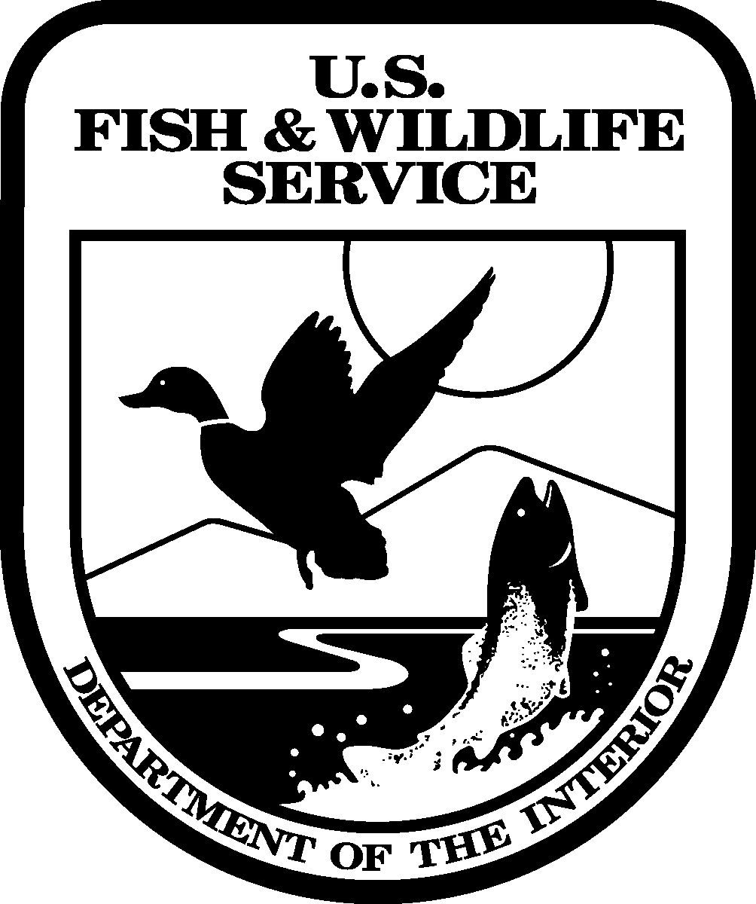
United States Department of the Interior
FISH AND WILDLIFE SERVICE

Request for Proposals
In Reply Refer To:
Fishery Restoration Work for the Klamath Restoration Program
Proposals Due: May 2, 2005

The U.S. Fish and Wildlife Service (Service) invites proposals for projects contributing to restoration of anadromous fish stocks of the Klamath River Basin, California. Within certain limitations, the Service may provide funds for this work to public agencies, non-profit organizations, Native American tribes, and individuals.

Fishery restoration work will be part of the Klamath River Basin Conservation Area Restoration Program (Klamath Restoration Program), a twenty-year program authorized by Congress in 1986. The Klamath Restoration Program is administered by the Service, with guidance provided by the Klamath River Basin Fisheries Task Force (Task Force) and Technical Work Group, which is composed of representatives from resource agencies, tribes and interest groups.

In this last year of funding for the Klamath Restoration Program, the Task Force has developed a more specific list of projects for which we wish to receive proposals of funding. Proposals should describe projects only within the following three categories:

1. Funding for a coordinator of watershed planning and project development in the upper portion of the Mid-Klamath Sub-basin of the Klamath River Basin. See map of the Sub-basins (Enclosure 1). A Draft Mid-Klamath Sub-basin watershed plan, including both upper and lower parts, has been prepared by the Karuk Tribe and indicates that the sub-basin should be divided in two parts. The coordinator will be responsible for developing the exact boundary with the lower Mid-Klamath Sub-basin watershed group in addition to normal duties of watershed coordination. This proposal amount should not exceed $30,000.

2. Funding for priority research, monitoring, and assessments with emphasis on fish health studies and coho studies. Funding in this category will not exceed $175,000.

3. Preparation of Reports on: a) Status of Anadromous Fish of the Klamath River (not to exceed $20,000), and/or b) Status of Anadromous Fishery Issues of the Mainstem Klamath River (from Upper Klamath Lake to the Estuary and mouth) (not to exceed $25,000).

Proposals that do not meet at least one of the descriptions, above, will not be evaluated or ranked. Proposals must be prepared in the format outlined in the enclosed Format for Project Proposal (Enclosure 5).

The AKlamath River Basin@ is defined here to include the Klamath River watershed, excluding the Trinity River. The Trinity River is excluded here because fish restoration in the Trinity River sub-basin is funded through a separate restoration program administered by the Bureau of Reclamation.

Parties interested in submitting proposals to accomplish work under this program should submit 15 hole-punched, legible copies. Please note that no faxes will be accepted. The proposals must have a U. S. Postal Service postmark dated no later than May 2, 2005, or they may be hand delivered no later than 4:30 p.m., May 2, 2005, to U.S. Fish and Wildlife Service, Yreka Fish and Wildlife Office, 1829 South Oregon Street, Yreka, CA 96097.

After proposals are received, they will be reviewed and ranked by the Technical Work Group (please see ranking criteria, Enclosure 3), with the final decision on funding to be made by the Task Force for funding in Fiscal Year 2006. If you have questions, please contact Laurie Simons or Darla Eastman at the address above or at laurie_simons@fws.gov or darla_eastman@fws.gov.

** IMPORTANT **

Project proposers must submit a SF-424, Application for Federal Assistance, and obtain and include a Dun and Bradstreet Data Universal Numbering System (DUNS) number with their project proposal. The DUNS number is a unique nine character identification number provided by the commercial company Dun & Bradstreet (D&B). Call D&B at 1-866-705-5711, if you do not have a DUNS number. The process to request a DUNS number takes about 10 minutes and is free of charge. Your project proposal may not be considered if a SF-424 is not included with your proposal.
If you are awarded by the U.S. Fish and Wildlife Service, you will be required to register with the Central Contractor Registration (CCR) in order to do business with the Federal government. The CCR is the primary vendor database for the Department of Treasury. The CCR collects, validates, stores and disseminates data in support of agency missions. You may register online with CCR at: www.ccr.gov.
Both current and potential government vendors are required to register in CCR in order to do be awarded contracts by Treasury. Vendors are required to complete a one-time registration to provide basic information relevant to procurement and financial transactions. Vendors must update or renew their registration annually to maintain an active status.

Enclosure 1
Sub-basins of the Lower Klamath River Basin

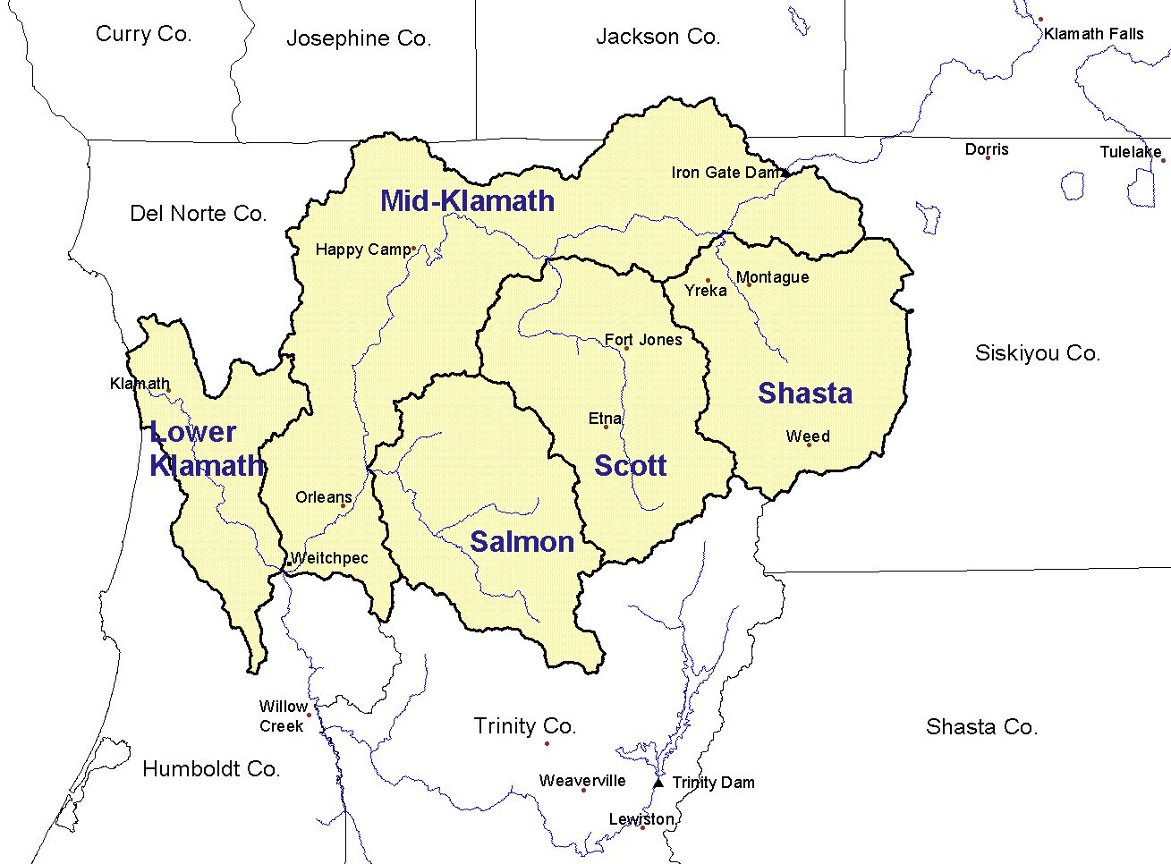
Enclosure 2
FORMAT FOR PROJECT PROPOSALS

PROPOSAL FORMAT:

Complete the attached summary sheet (Appendix 1) and include it as a cover for your proposal. If you have letterhead stationery, please use it only on the transmittal letter for the package. You must follow the format outlined in this section or your project may be rejected. Use separate pages for the cover and budget sections of the proposal and supporting material, such as maps, pictures, and drawings. Proposals and supporting material must be printed on 8.5 x 11 inch white paper.

Be brief. Keep it short and to the point.

ADDRESS YOUR AUDIENCE

Many people will be reviewing this proposal and their levels of expertise about your particular project will vary. Try to anticipate and answer questions.

1. Project Title

2. Proposer

Identify who is submitting this proposal (agency, tribe, etc.) and be sure to identify the contact person. Attach a Resume or other description of the education and experience of the persons responsible for project implementation (eg. project manager, contractor).

3. Program Information

Summarize information about the problem or opportunity addressed by your proposal. Place the project in context: What are the priorities for that area and the probability of providing measurable benefits?

4. Background

Provide enough background information to bring reviewers up-to-date on the need for this proposal. This will assist the Technical Work Group in ranking your proposal. In addition, provide qualitative and quantitative species information in the proposal if it is applicable and available. This information may be from a number of sources. Consult the Long Range Plan for the Klamath River Basin Conservation Area Restoration Program.

5. Project Objective(s)

State the objectives of your proposal in complete sentences. It is important that your project addresses at least one of the three category objectives described on page 1.

6. Tasks

State the specific actions which must be taken to achieve the project objectives.

7. Methods

Describe methods to be used.

8. Specific Work Products

Identify specific deliverable results of the project. Normally, project managers will be required to submit quarterly, annual and final project reports.

9. Project Duration

a. Identify project duration from the beginning of project through submittal of a final report. Note that duration of a project funded from Fiscal Year 2005 appropriations may extend beyond the end of the fiscal year.

b. Identify points at which decisions could logically be made to modify or terminate a project.

c. Provide a detailed project schedule to include:
Initiation of project.
Completion date for each milestone or major task.
Submittal dates for reports. (Usually 15 days after the end of quarter and 90 days after
completion of project.)

10. Permits

You will be responsible for securing all applicable permits for your project. Permits may include, but not be limited to, a Streambed Alteration Agreement from the California Department of Fish and Game.

On-the-ground (dirt moving) projects will be required to be in compliance with Sections 401 and 404 of the Clean Water Act, Sections 7 and 10 of the Endangered Species Act, and the National Historic Preservation Act of 1966, as well as Department of the Interior regulations on hazardous substance determinations. Project site surveys will be required in order to comply with these regulations. You should include the results of any completed archaeological or biological surveys in your proposal package. If surveys have not been completed, you may have to incorporate the cost of a survey into your proposal budget.

Necessary permits and landowner permission will be required prior to finalization of an agreement. Evidence of permits and landowner permission must be provided to the U.S. Fish and Wildlife Service, Yreka River Fish and Wildlife Office.

11. Employment of Targeted Groups

The Klamath Restoration Act states ATo the extent practicable, any restoration work performed under paragraph (2)(B) will be performed by unemployed:

- Commercial fisherman
- Indians
- Other person whose livelihood depends upon Area fishery resources.

12. Volunteer Contributions

The Klamath Act recognizes in-kind contributions by volunteers as contributions to the Klamath Restoration Program. Describe how your proposal would make use of volunteers.

13. Matching Funds

The Task Force realizes that we can make our restoration dollars go farther if other sources are found to match our investments. Seek matching funds and show these in your proposal. Indicate if these matches are state or federal matches. Also indicate other funding sources to which you have applied, or plan to apply during this year, to match this project.

14. Budget

Provide a detailed budget for the project. Detail how matching or in-kind contributions are determined. In-kind contributions may include donated labor, materials, or equipment. Matching funds are those funds contributed to the project from other funding sources. Successful proposals will be funded from Fiscal Year 2006 appropriations only. Administrative overhead should not exceed 15 percent, although the Task Force has funded projects with higher overhead in the past. Project costs, qualifying in-kind, and matching contributions must be incurred only during project implementation and must be directly tied to the overall project costs. All costs must be supported by appropriate invoices. The detailed budget should include line entries as described in the attached Estimated Budget Worksheet (Appendix 2). The Budget portion of your proposal will be carefully reviewed. Be sure that all costs are presented as described above, and all computations are accurate.

Appendix 1

KLAMATH RIVER FISHERY RESTORATION PROGRAM
FISCAL YEAR 2006
PROJECT SUMMARY SHEET

USFWS PROJECT NO. __________

Please complete items 1-14.

1. PROPOSER/ORGANIZATION:

2. ADDRESS:

3. CITY:

4. STATE:

5. ZIP CODE:

6. CONTACT PERSON:

7. TELEPHONE NUMBER: Office -
Home -

8. PROJECT TITLE:

9. OBJECTIVE:

10. FUNDING REQUESTED:

11. MATCHING FUNDS or IN-KIND CONTRIBUTIONS:

12. SUB-BASIN:

13. SPECIES BENEFITED:

14. PAST COOPERATOR: YES/NO
Appendix 2
ESTIMATED BUDGET WORKSHEET
PROPOSAL NAME
FISCAL YEAR 2006

Amount Amount Project
Requested Cost Share Total

PERSONNEL COSTS:

Type of Labor # of Hours Hourly Rate
List by Task
or type of labor
_________ $_________
_________ $_________

TOTAL PERSONNEL COSTS: $ $ $________

OPERATING EXPENSES: List by Specific Categories

Examples:
Supplies and Materials $ $ $________

Mileage:
_______ miles x ._______/mile = __________ $ $ $________

Per diem: for food and lodging $ $ $________

Administrative Overhead (____%) $ $ $________

TOTAL OPERATING EXPENSES: $ $ $________

TOTAL FUNDS $ $ $________

PERCENT COST SHARE: ______%
Enclosure 3
TECHNICAL WORK GROUP EVALUATION CRITERIA
REVISED FOR FISCAL YEAR 2006

CRITERIA MAXIMUM POINTS

1. Employment of target groups 10

2. Benefits to priority fish species and stocks 10

3. Ability of the proposer to successfully implement
the proposed project 10

4. Scientific validity and technical quality 25

5. Conforms to objectives described for each category
on page 1 25

6. Cost effectiveness including: pricing, resource 20
benefits/costs, development of matching funds,
and willingness of the proposer to contribute
funds or in-kind goods/services

TOTAL 100

Proposals that do not fit in the categories described on page 1, will not be evaluated or ranked.

