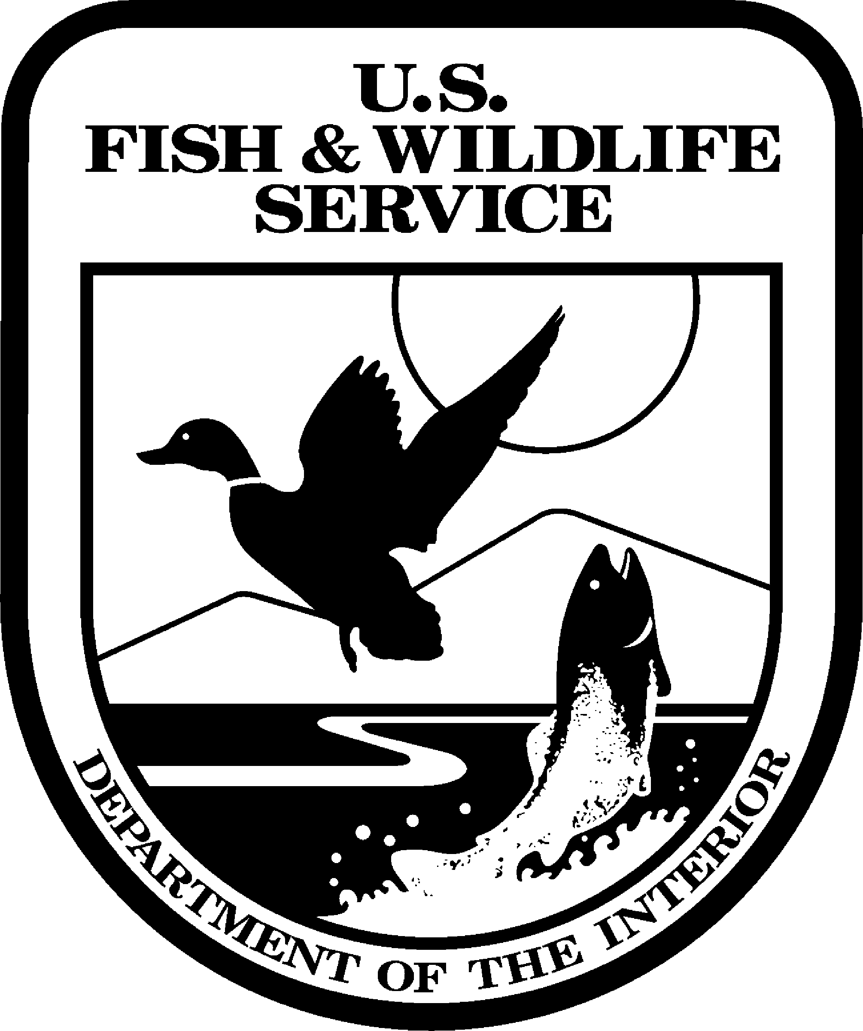

United States Department of the Interior
FISH AND WILDLIFE SERVICE
Klamath Basin National Wildlife Refuges

4009 Hill Road
Tulelake, CA 96134

TELE (530) 667-2231 FAX (530) 667-3299

Date: September 5, 2006

Contact: Dave Mauser (530) 667-2231 FOR IMMEDIATE RELEASE

Tulelake “Walking Wetlands” Tour to be Held September 8

On September 8th the public is invited to participate in a guided tour of the “Walking Wetlands” program on Tule Lake National Wildlife Refuge as well as two private farms in the Klamath Basin. The tour will start at the University of California’s Intermountain Research and Extension Center and run from 8:00 am to noon. The Center is located at 2816 Havlina Road in the town of Tulelake, California.

In the 1990s the U.S. Fish and Wildlife Service, Tule Lake Irrigation District, U.S. Bureau of Reclamation, and the University of California began an experimental program of rotating wetlands and croplands on the Tule Lake National Wildlife Refuge (NWR). In addition, a similar program was underway on the adjacent Lower Klamath NWR. Initial results indicate that diverse productive wetlands could be rapidly restored on former croplands. When returned to agricultural production, farmers reported increased crop performance with fewer agricultural inputs. As a result, the program has expanded in acreage on the Refuge lease lands and is in its initial stages on private lands.

For information contact Dave Mauser at 530-667-2231.

