Klamath Marsh Refuge Planning Meetings February 6 and 7

2/2/07 - Initial planning meetings for the 41,000 acre Klamath Marsh National Wildlife Refuge in central Klamath County, will be held at the Klamath Falls Shilo Inn (Clear Lake Room) on February 6th and at the Chiloquin Community Center on February 7th. Both meetings will begin at 6:00 p.m. and are expected to last about 2 hours. The meetings are intended to focus on developing a vision and goals for refuge management and to discuss significant issues and challenges facing the refuge.

The plan, known as a Comprehensive Conservation Plan, will serve as a guide for managing the refuge over the next 15 years. To date, two planning documents have been developed to provide background information about the refuge and allow interested participants an opportunity to make suggestions for managing refuge wildlife, habitats, and visitor services in the future. To receive these planning updates contact Dave Menke at (530)667-2231, Carol Damberg at (541) 783-3380 or Mark Pelz at (916) 414-6504. The updates and other information about the Klamath Basin Wildlife Refuge Complex are also available on the web site http//www.fws.gov/klamathbasinrefuges.
You can play a significant role in the development of this far-reaching plan by submitting comments and participating in public meetings.

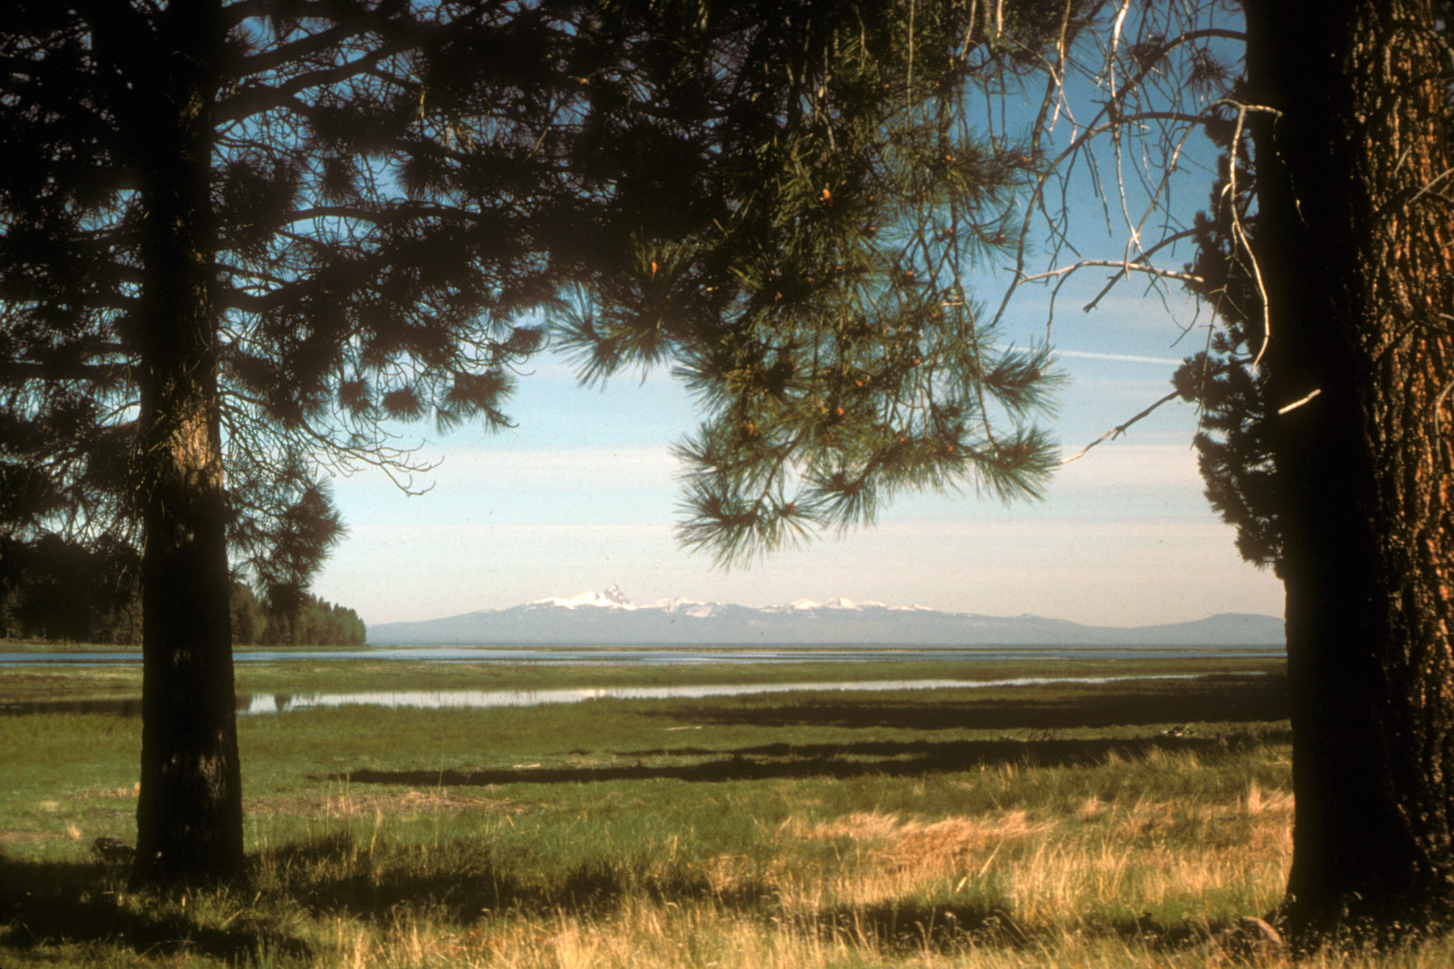

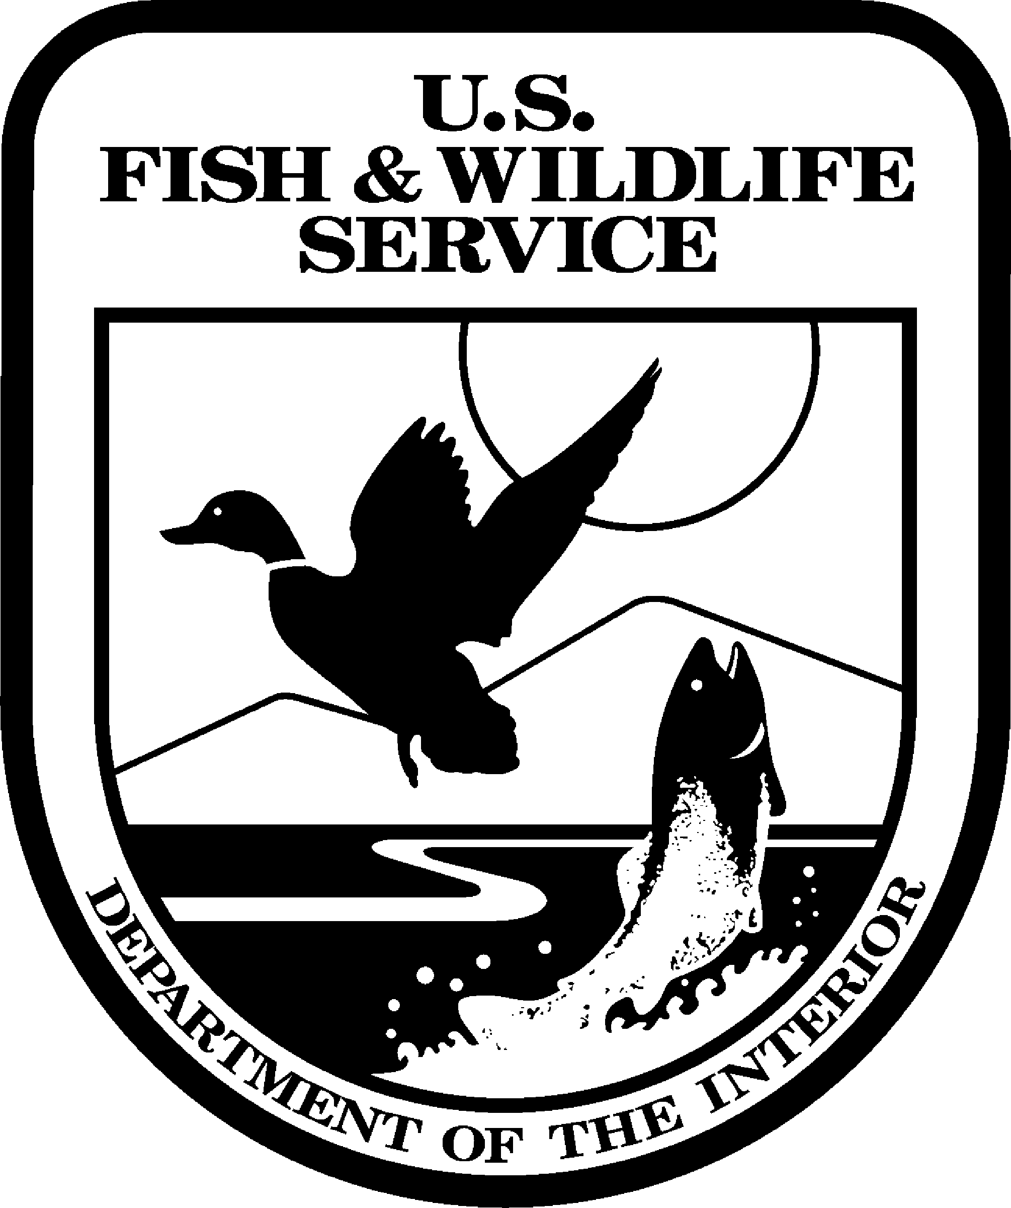

United States Department of the Interior
FISH AND WILDLIFE SERVICE

4009 Hill Rd
Tulelake, CA 96134

TELE (530) 667-2231 FAX (530) 667-3299
Date: January 29, 2007 FOR IMMEDIATE RELEASE

Contact: Carol Damberg (541) 783-3380; carol_damberg@fws.gov.

U.S. Fish and Wildlife Service to Hold Meetings for Klamath Marsh Refuge.

Klamath Marsh National Wildlife Refuge (NWR) will host meetings on February 6th and 7th to gather ideas and suggestions from the public concerning management of the refuge. Input from the meetings will help the refuge draft a Comprehensive Conservation Plan (CCP) to manage the 41,000-acre refuge for the next 15 years.

Refuge Manager, Carol Damberg emphasized that during the planning process, “We want to involve the public as much as possible in formulating future refuge management programs and activities.” The public scoping meetings are the first opportunity the public has to participate in this important planning process. Once the Refuge has gathered the scoping issues and concerns from interested parties a draft CCP will be developed and released to the public for further comments, Damberg said.

The meetings will consist of two short slide shows that will provide background information about Refuge management and the CCP Process followed by a general question period. Participants will then have a chance to visit with Refuge staff and provide either written or oral comments about the issues or concerns they would like to see addressed in the CCP planning process. The first meeting will take place on Tuesday, Feb 6, 2007 from 6 p.m. to 8:30 p.m. at the Shilo Inn in the Klamath Lake meeting room, 2500 Almond St. in Klamath Falls. On February 7^{th,} a second meeting will be held at the Chiloquin Community Center, 140 1st Avenue, in Chiloquin, Oregon from 6 p.m. to 8:30 p.m.

Verbal and written comments and questions are welcomed at the meetings and can also be submitted by March 7, 2007 via mail, e-mail or fax to: Mark Pelz, 2800 Cottage Way Suite W-1832, Sacramento CA, 95825; 916-414-6497 (fax) or Mark_Pelz@fws.gov. Periodic “Planning Updates” that provide information on the Klamath Marsh NWR CCP are available on the following websites: http://www.fws.gov/pacific/planning/ or http://www.fws.gov/klamathbasinrefuges/index.html

Klamath Marsh NWR is located approximately 55 miles north of Klamath Falls, Oregon in central Klamath County. The refuge protects marsh and upland habitats used by over 200 species of birds in addition to many mammals, reptiles, amphibians and fish. The Refuge was established in 1958 primarily to protect and enhance habitats for migratory birds. In addition to migratory water birds, key wildlife using the refuge include sandhill cranes, yellow rail, spotted frogs, white-headed woodpeckers, redband trout, bald eagles (nesting), Rocky Mountain elk and Neotropical migratory birds. Much of the planning undertaken at Klamath Marsh will focus on maintaining and enhancing the habitats on which these and other wildlife species depend. Refuge visitor services to be addressed in the planning process include wildlife observation and photography, fishing, hunting, nature interpretation and education. These programs will be evaluated in the planning process as well.

The U.S. Fish and Wildlife Service is the principal federal agency responsible for conserving, protecting and enhancing fish, wildlife and plants and their habitats for the continuing benefit of the American people. The Service manages the 95-million-acre National Wildlife Refuge System which encompasses 545 national wildlife refuges, thousands of small wetlands and other special management areas. It also operates 66 national fish hatcheries, 64 fishery resource offices and 78 ecological services field stations. The agency enforces Federal wildlife laws, administers the Endangered Species Act, manages migratory bird populations, restores nationally significant fisheries, conserves and restores wildlife habitat such as wetlands, and helps foreign governments with their conservation efforts. It also oversees the Federal Aid program that distributes hundreds of millions of dollars in excise taxes on fishing and hunting equipment to state fish and wildlife agencies.

SEE PHOTO AS SEPARATE ATTACHMENT


 

