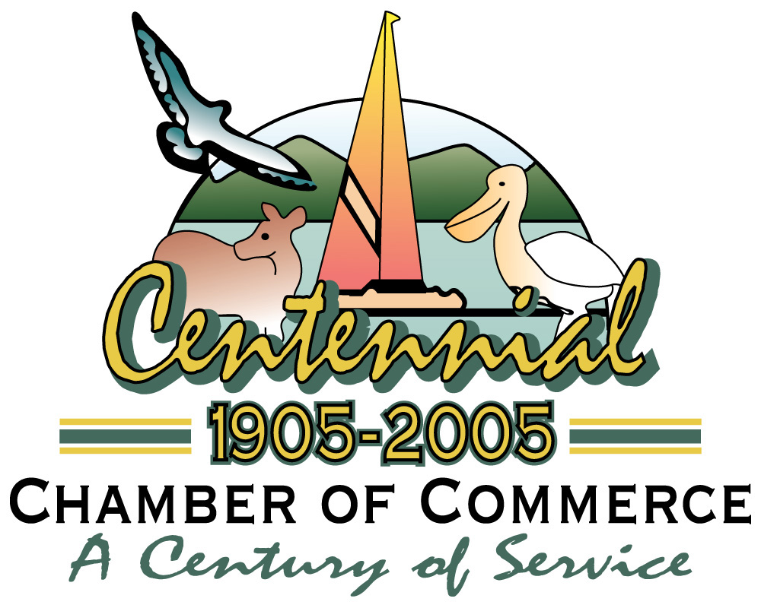

Klamath County Chamber of Commerce
706 Main Street  Klamath Falls, Oregon 97601
(541) 884-5193 Phone  (541) 884-5195 Fax
www.klamath.org

March 10, 2006

Dear Editor,

Your recent article “Managers to close salmon fisheries in Oregon and Northern California” on 3-7-2006 was way off the mark.

Your assertion that the closure of these fisheries is the result of actions from a farming project in the Klamath Basin whose farmers use less than 3% of the watershed is an absolute perversion of the truth. Furthermore, blaming the fish kill of 2002 on this same project is a complete fallacy. Placing the burdens of the entire watershed on this one small user is nothing more than harassment.

These are hard working business people have borne the burden of some of the most heinous miscarriages of justice. This was especially visible when their water was cut off because of artificially inflated lake levels to protect two species of sucker fish. In fact, the National Academy of Sciences, after reviewing the science behind this decision found unequivocally that the decision was without merit and that the water should not have been curtailed.

To now further exacerbate that wrong, people who do not reside in the watershed nor have any real understanding of it are forming “opinions” about it. Opinions not based in fact but rather environmental extremism that serves no other purpose but to continue to fuel a ridiculous us vs. them agenda.

This type of biased and meritless editorialism shows nothing more than callous disregard for the efforts of many watershed users who are working hard to collaborate. Rather than sitting on the outside tossing lead balloons at our communities why not try getting the real facts about what is occurring here and give your readers the truth.

Sincerely,

Stephanie Bailey
Executive Director
Klamath County Chamber of Commerce

Board of Directors

Joe Spendolini
Hire Calling & Graphic Press

Darin Rutledge

Klamath County

Dan Keppen

Dan Keppen & Associates

Reba VanAcker

Epicenter

Todd Andres
Running Y Ranch Resort

Charles (Chip) Massie
Antonio’s Cucina Italiana

Becky Wilson
Practical Marketing

Frank Goodson

Paradise Hill Real Estate

Beth Halvorsen
Sterling Savings Bank

Norm Holliday
Holliday Jewelry

Rob Siems
New Northwest Broadcasters

Scott Souders

ZCS Engineering
Debbie Vought
Citizens for Safe Schools

Staff

Stephanie K. Bailey
Executive Director

Sarah Weldon
Marketing & Program Administrator

Lilly Johnson
Administrative Assistant

“The Klamath County Chamber of Commerce is committed to Klamath County by advancing its economic vitality and quality of life through the education, promotion and networking of our members”

