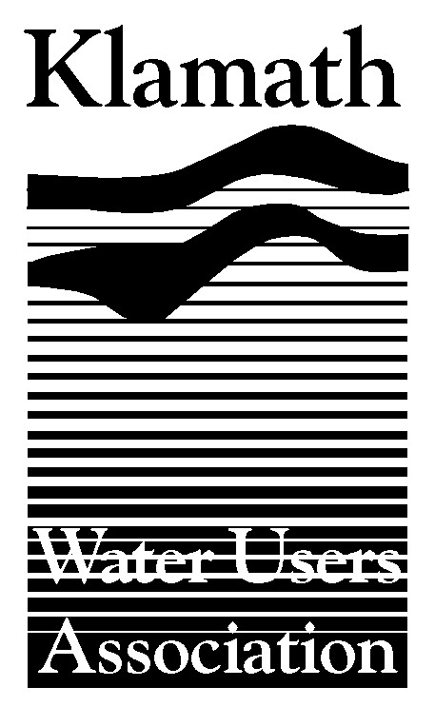
Klamath Water Users Association
2455 Patterson Street, Suite 3
Klamath Falls, Oregon 97603
(541)-883-6100 FAX (541)-883-8893
kwua@cvcwireless.net
www.kwua.org

MEDIA ADVISORY

FOR IMMEDIATE RELEASE

Contact: Greg Addington, Executive Director
greg@cvcwireless.net cell# 541.892.1409

The Klamath Water Users Association (KWUA) learned today, April 25, 2006 that Congressman Mike Thompson (D-CA) plans to introduce legislation in Congress to provide emergency relief for coastal fishermen and provide funding for Klamath restoration activity.

The legislation appears to have three primary components:

- It would provide $81 million in emergency appropriations for impacted commercial fishermen, tribes and related businesses in the region;

- It would direct the Department of Commerce to complete a Klamath Salmon Recovery plan within six months, and after completion of the plan $45 million would be allocated for conservation projects, including in river monitoring of diseases and parasites, additional ocean and river population monitoring, operation and maintenance of stream gauges for flow monitoring, fish passage on National Forest lands and restoration of aquatic habitats in the lower basin;

- The Department of Commerce would be required to report to Congress on the progress of the Klamath on a yearly basis.

Broadly, KWUA is on record as supporting the apparent goals of the bill, which include mitigation of impacts of fishing restrictions and improvement of Klamath salmon stocks. On Monday, April 24, KWUA sent a letter supporting declaration of a fishing disaster to the Secretary of Commerce. KWUA supports relief for fishing families, Tribes and communities who will be impacted by the federal harvest restrictions.

While we see the need for financial assistance to parties affected by fishing restrictions, we do have some concerns with the proposed legislative package. The environmental restoration provisions of the bill seem well-intended, however it is not clear how new money and a new process will compliment efforts already underway (see accompanying list).

Irrigators support the need to better understand the river through monitoring and measurement. There is much to learn about fish populations and the stressors that affect them. However it is important to make sure that efforts are coordinated and that funding goes to the agencies that are best qualified to conduct these activities. Unfortunately this legislation does not address that issue.

Finally, we are concerned that mandating a coho recovery plan be in place within a six month time-frame will not allow important, highly relevant processes to play out. These include finalization and National Academies of Science (NAS) peer-review of the Hardy flow study, the Bureau of Reclamation’s naturalized flow study, and ongoing collaborative processes to deal with salmon issues.

KWUA continues to support a comprehensive watershed-wide approach to recovery of all Klamath fish species as outlined in the 2004 Klamath report from the National Research Council of the NAS. Having not been contacted by the sponsors of this legislation, we are unclear how this legislation incorporates those peer-reviewed, scientific objectives.

We urge Congressman Thompson to approach this issue in a bipartisan manner. It is our understanding that members of Congress who represent areas of the Klamath River Basin and have sincere desire to help address these issues had no advance knowledge of the bill or any opportunity to help craft language that would ensure successful passage of any beneficial legislation. KWUA also urges that any consideration of the bill reflect the interests and inputs of stakeholders currently engaged in addressing these same issues in a constructive manner.

KWUA will further evaluate the bill in the near term and develop its positions and recommendations more fully.

###

A partial list of restoration activity and research currently underway appears to include many of the concepts in this legislative package.

Current Ongoing Restoration and Research Activity in the Klamath River Basin

Arcata Fish and Wildlife Office:

Salmon related modeling analyses including-

- Salmon runs over the period of record
- Determining the optimum flow for production
- Naturalized flow analysis
- Production estimates
- Composite suitability programming, to allow computation of escape and distance to escape cover
- Shasta and Scott River Habitat Assessment Study Planning Assistance
- Klamath River habitat suitability criteria development
- Klamath Spawning distribution and abundance

Additional Studies ongoing-
- Coho survival and migration behavior in relation to Iron Gate Discharge
- Collection of juvenile chinook by hydrologic reach for pathogen infection rates and histology
- Collection of juvenile coho for histology
- Habitat distribution and life history study plan
- Analysis of Klamath hydrology and fish returns
- Analysis of water samples for spore densities
- Water quality analysis of data and nutrients)
- Analysis of Shasta River spectral imagery for riparian and instream classification
- 2D hydrodynamic analysis of Pecwan riffle for adult fish passage
- 2D Hydrodynamic and habitat modeling Training

Karuk Tribe:
- Water quality collection: Data sondes and nutrient suite
- Big Bar and Salmon River outmigration trapping
- Radio telemetry of salmon smolts during adverse mainstem Klamath conditions
- Habitat evaluation of radio tagged, juvenile coho

Yurok Tribe:
- Water quality collection (Data sondes and nutrient suite)
- Habitat evaluation of radio tagged, juvenile coho

Salmon River Restoration Council:
- Big Bar and Salmon River outmigration trapping
- Otolith collection for microstructural analyses
- Radio telemetry of salmon smolts during adverse mainstem Klamath conditions

Siskiyou RCD:
- Habitat Assessment Study Plan Development
- Habitat Inventory
- Limiting Factor Analyses

Shasta RCD:
- Habitat Assessment Study Plan Development
- Remote Sensing for GIS Analysis of Spectral Imagery

Idaho State University:
- Hydrological analysis of departure for the Klamath and significant tributaries

Bureau of Reclamation Funded:
- Juvenile coho survival and migration behavior in relation to Iron Gate releases
- Mainstem Klamath River adult coho spawning surveys
- Development of a Conservation Implementation Program, including salmon considerations

Trinity River Restoration Program:
- Outmigration monitoring at Willow Creek
- Pre and post channel reconstruction habitat analyses
- Outmigration Database support
- Outmigration monitoring coordination
- TWGs and many subcommittees

Otolith Microstructural Analyses:
- Trinity River Hatchery and natural
- Iron Gate Hatchery
- Salmon River spring chinook

Section 10, NMFS Research Permit:
- Coverage for a wide variety of studies and incidental take of coho
- Recent modification gave coverage for direct take of coho for disease analyses

