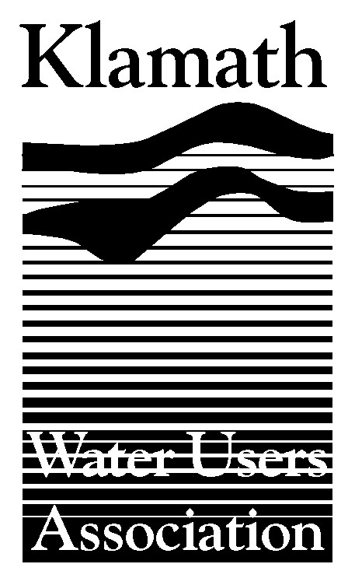
Klamath Water Users Association
2455 Patterson Street, Suite 3
Klamath Falls, Oregon 97603
(541)-883-6100 FAX (541)-883-8893
kwua@cvcwireless.net
www.kwua.org

KWUA RESPONSE TO MEDIA ACCUSATIONS DIRECTED AT THE KLAMATH PROJECT
RE: Potential Salmon Season Closure

Contact: Greg Addington, Klamath Water Users Association
Phone: 541.883.6100
greg@cvcwireless.net

General Points for Consideration

- Focusing on one aspect of a complex river and ocean ecosystem is irresponsible, negligent and will do nothing for the overall health and recovery of salmon. All stressors to fish including dams, disease, predation, ocean conditions, historic watershed and habitat modifications, land use practices and harvest must be considered.

- The Klamath Water Users Association (KWUA) supports rural and coastal communities in Oregon and California. We want to see fisherman and Tribes catching fish. We see the proposed closure of the 2006 fishing season as devastating an action as shutting off the Klamath Irrigation Project in 2001. The benefits are debatable and unknown, but the adverse impacts on people and communities are assured.

- KWUA is actively engaged with many other parties in efforts to protect and restore fisheries. Any solutions will likely be multifaceted, but solutions will not result from myopic and misinformed attack on the Klamath Project.

- This is as much a regulatory problem as anything. There will be large numbers of fish returning to the river, but they will be hatchery fish, not ‘natural spawners’. The current system that is in place does not adequately reward participation in fisheries restoration or provide security for those that rely on harvesting fish.

- If the answer is as simple as needing “cool water” perhaps some portion of the tens of millions of dollars spent on salmon habitat and recovery in the Klamath Basin should have been spent on developing deep and cold off-stream storage rather than depending on warm, shallow, naturally eutrophic water from Upper Klamath Lake.

- Charges that the current administration has changed water management policy by allocating more water to agriculture are simply not true. More water has been provided for flows in the Klamath River under the current administration than under the previous administration. In 2001, the current administration made and implemented the decision under which 170,000 acres of Klamath Project farmland went dry. In comparable water availability conditions in 1994, nearly all irrigation demands were met. Between 2002-2005 farmers and ranchers have contributed between 20,000 acre-feet and 100,000 acre-feet of water to the Klamath River system through the environmental water bank program. 2006 marks the second straight year where the Project will not use 100,000 acre-feet of water originally intended for irrigation purposes.

- Consider the following facts (information provided by U.S. Bureau of Reclamation):

  - 2004 NRCS Upper Klamath Basin Assessment: There are a little over 500,000 acres of irrigated land above Iron Gate Dam. The Klamath Project represents about 188,000 acres or 38% of the total.

  - In 2005, the Klamath Project delivered Upper Klamath Lake/Klamath River water to 157,540 irrigated agricultural acres and 32,175 acres of non-agricultural wetlands, including two National Wildlife Refuges. There is a maximum of 169,041 irrigable agricultural acres within the Klamath Project that are irrigated from Upper Klamath Lake/Klamath River water.

  - From 1961 through 2004, Klamath River water released at Keno, below the Klamath Project, averages 82% of available Upper Klamath inflows during the irrigation season (April through September) and 85% of annual Upper Klamath Lake inflows. In comparison, the new Trinity River agreement is only required to release 50% of inflows which is an increase from the previous releases of approximately 20%.

  - Natural Flow Study Estimates vs. Historical Klamath River Flows: 51 years - 1949-2000: (Numbers are in thousands of acre feet)

Annual Avg Basis
Natural Flow (of the Klamath River) 1,307
Historical Flow (post development) 1,263

Historical/Natural 97%

KWUA perspective: Irrigation of all land above Keno, roughly 350,000 acres +/-, which includes Upper Basin ‘Off-project’ lands, is done using only 3% of the “natural flow or a net depletion of 44,000 acre feet of water per year.

2002 Fish Die-Off

- We reviewed the CDFG report and found it to be “fatally flawed”. This information was included in testimony in the lawsuit that the Pacific Coast Federation of Fishermen’s Association (PCFFA) filed against the federal government regarding the die-off.

- Flows in late summer of 2002 were not atypically low or historic lows.

- Further, the National Research Council (NRC) in its final 2003 report found “....no obvious explanation of the fish kill based on unique flow or temperature conditions is possible” and “It is unclear what the effect of specific amounts of additional flow drawn from controllable upstream sources (Trinity and Iron Gate Reservoir) would have been. Flows from the Trinity River could be most effective in lowering temperature.” (p. 8).

- During the teleconference held by the National Academy and the Interior Department in October 2003, Dr. William Lewis, Chair of the NRC Committee on Endangered and Threatened Fishes in the Klamath River Basin, said the following to reporters regarding the fish die-off and the CDFG draft report:

Lewis: "A simple explanation based on a unique low flow or high temperature is not possible."

A reporter from USA Today observed: "CDFG says the Klamath Project killed the fish. Is NAS saying they are incorrect?"

Lewis: "There must be some other dimension to this, other than flow or temperature. The CDFG findings are skeptical. The cause of the fish kill is unproven at the moment."

- Eager media outlets who lack the facts and feel the need to have a ‘bad guy’ to blame have accepted stereotypes and simplistic views of the environment, promoting division and driving attention away from collaborative and real solutions.

