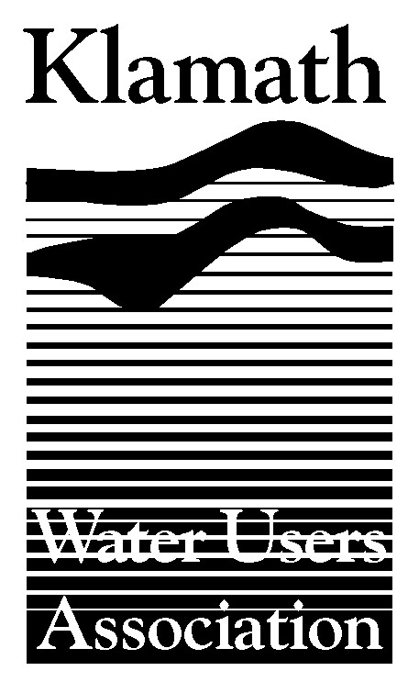
Klamath Water Users Association
2455 Patterson Street, Suite 3
Klamath Falls, Oregon 97603
(541)-883-6100 FAX (541)-883-8893
kwua@cvcwireless.net
www.kwua.org

Key Findings of National Research Council Klamath River Study
Should Compliment Watershed-Wide Settlement

Sensational media headlines and anti-farm spin could make it more difficult

For Immediate Release: December 5, 2007
Contact: Greg Addington, Klamath Water Users Association (KWUA)
Office- 541.883.6100 Cell-541.892.1409

Klamath Project water users were initially encouraged by key findings included in a Klamath River flow report released by the National Research Council (NRC). The NRC report focused on two recent studies that attempted to better understand the Klamath River basin in Oregon and California. The report concluded that both studies – one completed by Utah State University and the other by the federal Bureau of Reclamation - would be more useful to decision makers if a comprehensive analysis of the basin were conducted to identify all research and management needs.

Dr. William L. Graf, professor of geography at the University of South Carolina and chairman of the Klamath review committee says, "Science is being done in bits and pieces, and there is no conceptual model that gives a big picture perspective of the entire Klamath River basin and its many components, as a result, the integration of individual studies - such as the two examined by the committee - into a coherent whole has not taken place, and it is unlikely to take place under the present scientific and political arrangements."
Past studies have focused exclusively on the main river ignoring its many tributaries, the panel said in their report.
"It's like trying to understand a tree by only examining its trunk and not assessing its branches," Graf said.
Water users have long agreed with the NRC report’s conclusions about the importance of downstream tributaries to salmon health. They also support the committee’s finding that a comprehensive approach is what’s needed on the Klamath.
"This is encouraging news, because this type of philosophy underscores the approach we have been advocating for many years,” said Luther Horsley, president of the Klamath Water Users Association (KWUA). “We have consistently advocated that the challenges of the Klamath River can only be solved on a coordinated, watershed-wide basis."
However, recent media headlines and reaction from special interest activists regarding the report focus more on sensationalism and spin than on the true content of the document, which is a wearisome, but predictable distraction to many.
“There is a small cadre of anti-family farm groups out there who pounce on this kind of thing time and time again for their own political gain. It’s even more frustrating when we are bending over backward to try to work with parties we have been in conflict with in the past,” said Greg Addington, KWUA Executive Director.
Despite these disruptions, Klamath irrigators remain committed to a comprehensive settlement process and to giving their members an opportunity to provide input and feedback on the outcome of those negotiations.
While hundreds of millions of dollars of government funding has been spent on a wide range of restoration and water conservation measures up and down the Klamath River, Addington and other KWUA officials have encouraged federal and state agencies to avoid the fragmented approaches which have occurred in the past.
“A collaborative and coordinated watershed-wide approach can shift random acts of restoration into a strategy that really helps tribal and farming communities, fishermen, and fish and wildlife,” said Addington. “We think the agencies are committed to that type of process as we move forward together.”
The latest NRC report shows that the two completed flow studies are limited in their effectiveness because they do not account for a comprehensive view of the entire watershed, its ecological status, or the research and management needs of the entire basin. KWUA and other parties, including various tribes and conservation groups, have tried to focus on constructive solutions in an ongoing settlement process which many hope will create the comprehensive framework that is workable and acceptable to Klamath River communities.
"The settlement process provides real hope that we can get away from eternal conflict and focus on solutions," said Horsley.
-###-
The Klamath Water Users Association is a nonprofit corporation that has represented Klamath Irrigation Project irrigators since 1953. KWUA members include rural irrigation districts and other public agencies, as well as private irrigation companies operating in California and Oregon.

Summary Conclusions and Recommendations of the National Research Councils’ Committee on Hydrology, Ecology and Fishes of the Klamath River Basin

(Prepared by KWUA)
General

- Both studies have “admirable attributes” and some utility.

- “The committee’s considerations of science and decision-making in the Klamath River basin identified the same overarching concerns at almost every turn. The committee found that science was being carried out piecemeal, sometimes addressing very important questions, but not linking them to other relevant questions and studies.” – (pg. 145)

- “…the committee found shortcomings in the Natural Flow and Instream Flow studies that are sufficiently serious that the committee questions whether the studies can guide decision making effectively.” – (pg. 145)

Natural Flow Study

- “The basic approach used by USBR researchers to estimate the flows of the river without the upstream influence of dams and withdrawals relied on a ‘black box’ method of accounting for flow…” - (pg. 148)

- “Calculations of the fate of water in the upper basin related to evapotranspiration (ET) were not done according to the best current methods.” – (pg. 148)

- “The Natural Flow Study did not adequately take into account the role of groundwater in the system.” – (pg. 148)

- “…the Natural Flow Study did not address the issue of changes in land use and land cover.” (pg. 148)

- “The Natural Flow Study failed to adequately model the connection between the Klamath River and Lower Klamath Lake.” – (pg. 148)

  - “The inadequate and coarse-grained modeling of such a potentially important interaction reduces the utility of the natural flows calculated by USBR (2005).” – (pg. 149)

- “The committee concluded that the Natural Flow Study includes calculated flows that are at best first approximations to useful estimates of such flows. The present version of the Natural Flow Study is less than adequate for input to the Instream Flow Study and for day-to-day decision making regarding flows to benefit the listed and other anadromous fish species in the Klamath River downstream from Iron Gate Dam.” – (pg. 149)

Instream Flow Study (Hardy)

- Despite some strengths (in some of the models, processes and variables used), “the committee found important shortcomings in the Instream Flow Study and its use of models and data. Two shortcomings-- use of monthly data and lack of tributary analyses—are so severe that they should be addressed before decision-makers use the outputs of the study.”- (pg. 150) Emphasis added.

- “The Klamath River is not a confined gutter for rainwater, and therefore analyzing the river without considering its tributaries is akin to analyzing a tree by assessing only its trunk but not its branches. The previous NRC report on the Klamath River basin (NRC 2004a) also emphasized the importance of understanding the lower Klamath River tributaries and including them in restoration plans, especially for coho salmon.” – (pg. 151)

- The Intream Flow Study also exhibits modeling shortcomings. First, the study did not include important water-quality attributes, such as dissolved oxygen levels, nutrient loadings, contaminants, and sediment concentrations, each of which has important implications for the vitality of the fish populations of the Klamath River basin.” – (pg. 151)

- “…there was a lack of a thorough assessment of the relationship between flow-data time series and the behavior of different species and life stages, and the population dynamics of coho and Chinook salmon.” – (pg. 151)

- “…While the empirical tests and the bioenergetic and SALMOD model comparison to existing river-flow conditions suggest that the recommended flows offer some improvement over the current flow regime, they do not substitute for a rigorous statistical test of model predictions…” – (pg. 151)

- By missing these attributes (technical details described on pg. 152), the Instream Flow Study is seriously impaired.” – (pg. 152)

Bottom Line

Taken from pg. 153 –

“…the two studies do not allow for a detailed and practical analysis of tradeoffs among various flow-management regimes with respect to benefits and costs to the anadromous fishes in the river and to the agricultural and other interests in the basin. Before these system models can be used to guide management more specifically and with greater confidence, a more effective capacity for integrating the shortcomings will need to be addressed. The most critical shortcomings of the Natural Flow study are its inadequate treatment of linkages between the Klamath River and Lower Klamath Lake, and its provision of only monthly, rather than daily, time steps for hydrologic data. For the Instream Flow study, the most critical shortcomings are its lack of analysis of the Klamath River’s tributaries and its use of monthly instead of daily, flow values.

