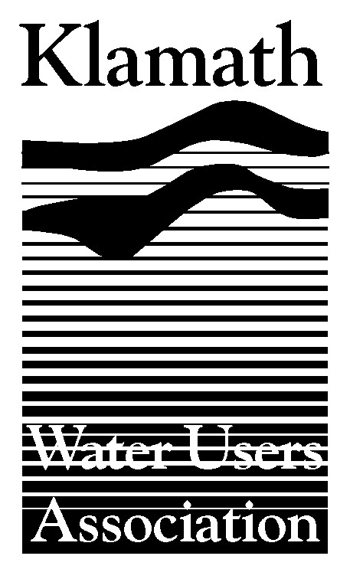
Klamath Water Users Association
2455 Patterson Street, Suite 3
Klamath Falls, Oregon 97603
(541)-883-6100 FAX (541)-883-8893
kwua@cvcwireless.net
www.kwua.org

The Honorable Carlos Gutierrez
Secretary
U.S. Department of Commerce
14th and Constitution Ave., NW
Room 5516
Washington DC 20230

April 24, 2006

Subject: Restriction of Commercial Salmon Harvest

Dear Secretary Gutierrez,

The Klamath Water Users Association (KWUA) respectfully requests that steps be taken to provide assistance for coastal communities, Tribes and commercial fishermen who will bear the burden of a decision to severely restrict Salmon harvest along 700 miles of coastline in Oregon and California this year. We urge NOAA Fisheries and the Department of Commerce to give prompt and positive consideration in declaring a fisheries disaster.

Weak and/or changing ocean conditions, drought, naturally poor Klamath River water quality, predation, disease and parasite issues have all led to weak Klamath River salmon stocks. Addressing these problems will require that local, state and federal agencies as well as stakeholders throughout the basin focus on a comprehensive approach. KWUA draws your attention to, and strongly supports, the October 2004 signing by the states of California and Oregon and the Bush Administration of the historic "Klamath River Watershed Coordination Agreement". The agreement –signed by California Governor Arnold Schwarzenegger, Oregon Governor Ted Kulongoski, and four of President Bush’s cabinet level secretaries – underscores the commitment of these parties to solve the fisheries challenges of the Klamath River on a watershed-wide basis. As an organization, we continue to be actively engaged in the FERC Settlement process with other stakeholders to find long-term solutions to some of the very difficult issues in the Basin. We look forward to continued work with NOAA Fisheries and others in that effort.

We earnestly request that as Secretary of Commerce you use your authority under Section 312(a) of the Magnuson-Stevens Fishery Conservation and Management Act to determine that there has been a fishery resource disaster for the reasons outlined above.

Thank you for considering the views of our organization. We look forward to a long-term and constructive effort to protect salmon and rural communities.

Respectfully,

Greg Addington
Executive Director

