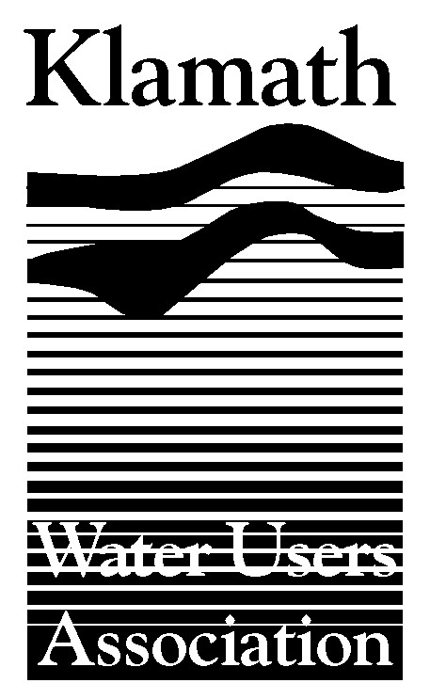

Klamath Water Users Association
2455 Patterson St., Suite 3, Klamath Falls, OR 97603
541.883.6100 * Fax 541883.8893 * kwua@cvcwireless.net

July 27, 2005

Mr. Dan Thorndike, Chairman
Oregon Water Resources Commission
725 Summer Street NE, Suite A
Salem, OR 97301

RE: Comments Regarding Petition for Withdrawal or Emergency Rulemaking – Klamath Basin

Chairman Thorndike, members of the Commission and Director Ward;

My name is Greg Addington and I am the Executive Director of the Klamath Water Users Association (KWUA). We appreciate the opportunity to provide our input with regard to the petition to withdrawal from further appropriation all the groundwater and surface waters of the Klamath and Lost River basins.

KWUA is a non-profit corporation that has represented Klamath Irrigation Project farmers and ranchers since 1953. KWUA members include rural irrigation districts and other public agencies as well as private concerns who beneficially use water on both sides of the Oregon-California border. KWUA focuses on issues that affect thousands of people including farm and ranch families, local businesses and our rural communities. Local water users also play an important role in Klamath Basin wildlife conservation activities, including efforts to provide environmental water for increased Klamath River flows as well as providing water to two national wildlife refuges. We are also actively engaged in environmental restoration activities underway in a variety of forums.

The 2001 federally-declared water cutoff resulted in impacts to agriculture and our local communities, impacts that can still be felt today. In addition, the threat of future curtailments of water is a constant threat that we deal with on an almost daily basis. The Klamath Basin remains a target for those groups who focus on a few species at the expense of many others, including the people who live here. The situation should underscore the important link between irrigated agriculture and the vitality of over 430 species of wildlife that call the Basin their home.

Summary of KWUA Position and Concerns

- We oppose the petition in its entirety and take issue with many of the purported facts in it. The petition uses half-truths and only cites parts of documents and reports without acknowledging differing facts and science that is available.

- We support the Department’s recommendation to deny the petition. OWRD has made and is capable of making case by case decision with regard to allocation of water based on merit using the best data available as determined by experts within the department.

- There are procedures currently in place to deal with ground and surface water appropriation issues. The Water Allocation Policy (OAR 690-410-070).

- Ground water pumping is strictly monitored and regulated by the Water Resources Department.

- This same petition was denied by the Commission in 2002. Despite any claims from petitioners, there is no new relevant information in this petition.

- We are concerned about the timing of this petition, this is the busiest time of year for producers to get involved and travel to Salem to defend their position. In addition it could be perceived that the petitioners are trying to take advantage of the fact that 4 new commissioners have been appointed to the Commission and may not have the “institutional” memory that led to the denial of the 2002 petition.

- The listed petitioners have continually used the courts, federal and state agencies, and news media to reduce flexibility and increase hardships on agriculture within the Basin, as opposed to working with agricultural organizations and the local community to solve problems.

- Granting of this petition will further reduce the options available for agricultural producers, could result in less water available for the Bureau of Reclamation’s environmental water bank and could have negative implications for two national wildlife refuges.

- This petition could also affect any new storage proposals in the Basin. Storage may in fact be the long term answer to many of the problems faced in the Basin. We are unclear about the impacts this action would have on future storage proposals.

- Throughout the west and particularly here in Klamath there is a need to look at and develop new supply initiatives including surface water storage and groundwater development.

- The Petitioners seem to support the use of the Bureau of Reclamation’s environmental water bank, yet they denounce the pumping of ground water which is used to supply the bank.

- The petition would lead you to believe that farmers are the only ones who would develop groundwater resources. After 2001, the state of Oregon appropriated $3 million for the development of groundwater pumping in the Basin.

There is no one silver bullet for solving the problems of the Klamath Basin. The relative importance of improved groundwater management is evolving through constant study and monitoring. What is clear is that groundwater management is one of the many actions required to reach a balanced solution in the Basin. Other actions include incorporating strong science and meaningful restoration activities throughout the Basin, improving storage capability, and developing other water management activities. Meaningful progress on all of these fronts can – and will- be made through cooperative efforts between local, state and federal interests.

We firmly believe that the subject petition – if approved – will deal a blow to the potential for cooperative partnerships, eliminate water management flexibility, and increase the vulnerability of local farmers, ranchers and communities. We suggest that this is exactly what the petitioners desire. Unfortunately, their zealously can affect the fate of the local economy, over 430 other species of wildlife, and the refuges that rely on Klamath Project water.

We respectfully request that you reject this request and terminate any further consideration of this flawed and dangerous petition.

Respectfully Submitted,

Greg Addington
Executive Director

