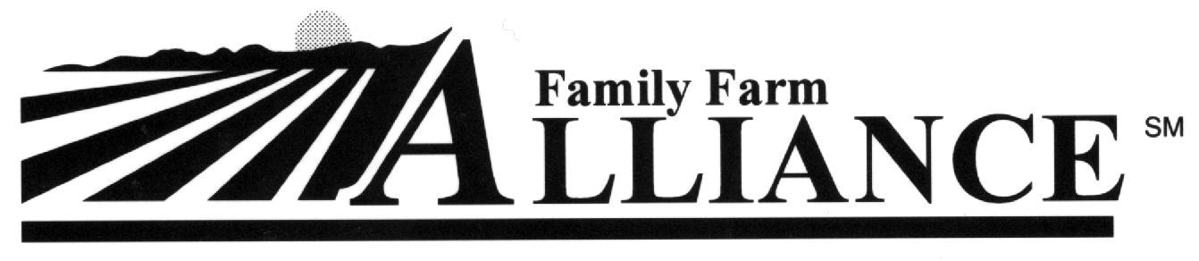

Dec. 11, 2006
.

Issue Alert

Congress Passes Rural Water Bill

Sends it to President Bush for Signature

C

Bill Co-Sponsors in the U.S. Senate

S. 895 was authored by Senator Domenici (New Mexico). Cosponsors in the Senate included Jeff Bingaman (NM), Robert Bennett (UT), Conrad Burns (MT), Byron Dorgan (ND), Dianne Feinstein (CA), Tim Johnson (SD), Jon Kyl (AZ), Lisa Murkowski (AK), and Ken Salazar (CO).

ongress on Saturday passed the Rural Water Supply Act (S. 895) authored by Chairman Pete V. Domenici and cosponsored by Ranking Member Jeff Bingaman, both of New Mexico. Saturday’s Senate passage followed a successful House vote last week, which means that the bill is now headed to President Bush’s desk to be signed into law.

This bill will authorize the Bureau of Reclamation (Reclamation) to build rural domestic water supply projects that meet certain engineering and feasibility criteria. The Bush Administration strongly supported the bill because it believes the measure would help Reclamation keep resources focused on its core missions. Currently, Congress authorizes rural water supply projects on an ad-hoc basis, adding large construction obligations to Reclamation’s already strained budget.

Of perhaps greater importance to Western irrigators are the bill’s provisions to authorize a new federal loan

guarantee program to help irrigation districts finance major operation and maintenance costs.

The alternative financing mechanism proposed in S. 895 provides a government loan guarantee to allow local entities to amortize expensive operation, maintenance and replacement projects.

“The loan guarantee program will be helpful to some local agencies struggling to afford repairs to federally owned facilities,” said Alliance Executive Director Dan Keppen. “By making it easier for local agencies to meet their financial responsibilities, this bill will make it easier to protect the federal investment in the West water supply infrastructure.”

“Many Bureau of Reclamation projects are nearing 100 years of age,” said Chairman Domenici. “I have found that many who depend on these projects for their water are not able to afford operation, maintenance and rehabilitation associated the projects. It is sometimes very difficult for smaller communities to provide high quality water access to its citizens, so I’m looking forward to this bill becoming law so that they can have another avenue for help.”

The Senate first passed the bill in November 2005. The Family Farm Alliance gave qualified support to this legislation during hearings conducted before the House Resources Committee and the Senate Energy and Natural Resources Committee earlier this year. The Alliance was also actively involved in negotiations with House and Senate committees to expand the bill’s benefits for irrigation districts. The bill’s language was altered in the House in part to address concerns raised by the Alliance, making another Senate vote necessary.
Amendments to the Rural Water Supply Act (S. 895) requested by the
Family Farm Alliance

Requirement for a report to Congress on how much funding and personnel the Bureau allocates to the new Rural Water Supply Program;

Reduced authorization of appropriations;

Provision allowing the use of new federal loan guarantees for improvements to local water infrastructure;

Requirement for a report to Congress on implementation of the loan guarantee program;

Clarification that the legislation doesn’t affect other Reclamation laws; and

Requirement for a report to Congress on obstacles to timely title transfers.

The changes agreed to by the Senate Committee staff were specifically intended to address the concerns and recommendations that the Alliance raised in letters and testimony during the past year. These include concerns about the expansion of Reclamation’s mission during a time of tight funding and the need for close scrutiny of any new spending and allocation of personnel to the new Rural Water Supply program. The Alliance further recommended expansion of the bill's federal loan guarantee program to help irrigation districts improve the operation and efficiency of their own infrastructures.

The revised bill also takes a step toward addressing an issue raised by the Alliance repeatedly over several years: the slow and costly process for transferring title to Reclamation facilities to local authorities.

“We truly appreciate that staffers from the Senate Energy and Natural Resources Committee and the House Resources Committee were willing to work with us to address concerns raised by irrigators and the districts that serve them,” said Keppen. “The Bush Administration, and in particular, Assistant Interior Secretary Mark Limbaugh, also deserve kudos for hard work on this matter. This is a great win for water users and their projects.”

In addition to getting support from the Alliance, the Rural Water Supply Act was also endorsed by the National Rural Water Association, the Western Governors’ Association, the Western States Water Council, and the National Water Resources Association.

