April 2005 Family Farm Alliance Monthly Briefing Page 3

Feeling Farming’s Pinch First Hand
Alliance Co-Founder’s Family Says Farewell To Ag Heritage

If ever there were an ideal illustration of a family farmer fighting an uphill, grassroots battle to rationalize federal water policy while ultimately and symbolically losing the war of modern agricultural economics, it would be Judy Brown.
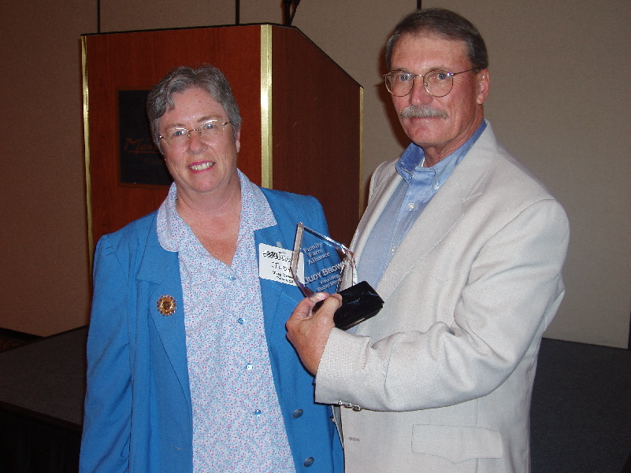
A co-founder of the Family Farm Alliance more than 17 years ago and an officer and director ever since, Brown and her family have surrendered to farming’s relentless economic pressures. They have sold their Glenn County ranches in Northern California’s Sacramento Valley.
Selling the family’s ranch property, equipment and business was a decision long in the making but has led to a transition that has been emotional and challenging, although Brown says her family members have tried to not let it get them down.
Judy Brown is honored for her years of long service as a Family Farm Alliance charter member and long-time Secretary-Treasurer during a presentation by new President Pat O’Toole at the Alliance’s Annual Meeting in Las Vegas. She stepped down as Treasurer a year ago and soon plans to resign as a Director.
“We’re coping with it; we’re moving on,” she says. “We just kind of got worn down by all of it.”
Brown grew up on the ranch near Orland. She was away eight years, including college and postings her husband had in the Army in Virginia and Colorado. She attended the University of California, Davis and graduated in food science at UC Davis, where she also earned a master’s degree.
Back in Orland, Brown’s entry to farming was through the office. “It took quite a while for me to be looked upon other than the bookkeeper and secretary,” she said.
That changed after the ranch began growing cotton and when her father died, Brown’s management role became more acute.
She’d had some involvement in politics and in 1981-82 Brown took part in the debate over passage of the Reclamation Reform Act, including testifying in a Congressional field hearing in nearby Willows.
“I had no idea it was going to be sort of a lifetime commitment,” she said.
In 1990, Brown learned from the family’s attorney, J. Mark Atlas, of a meeting being held in Fresno over concerns with federal water programs.
“The idea for the Family Farm Alliance was born at a cocktail party there in Fresno,” she said.
The Alliance became a fragile reality. Brown became Secretary-Treasurer.
“When something needed to be done, I’d call our first President, Bill Scott, or he’d call me or our attorney, Gary Sawyers,” she said The first big test for the Alliance was simply getting a basic structure in place.
“At our first annual meeting in Sacramento we had like 12 people,” she said. “We were flying by the seat of our pants.”
The Alliance’s first activity remains its most important – farmer lobbyists.
“All of the big agencies had lobbyists,” Brown said. “We had a big impact because we had real farmers telling the story.”
THE END of the family’s farming operation was a long time in the making.
“Twenty-five years ago it seemed that the future of agriculture was limited,” Brown said. She and her husband did not encourage their children to follow careers on the farm.
She had hoped to stay with farming for at least another decade and had been helped by some profits.
Then in 1998 came a big rainfall year that created what Brown called “a triple whammy. Crop production was bad, costs soared and prices tanked. We never really recovered from that.”
They operated on cash reserves but agreed they wouldn’t borrow to stay in business.
“We just kept saying, ‘When is it going to turn around?’ ” Brown said.
Finally, two year ago, they asked each other, “Do we really want to keep spinning our wheels?”
The answer was no. The result is that the realities of modern agricultural economics caught up with yet another farming family.
At least the saga is ending on a bright note, Brown said. “We’re getting out with cash in our pocket!”

April 2005 Family Farm Alliance Monthly Briefing Page 4

At The Alliance’s Annual Meeting
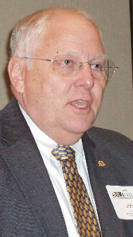
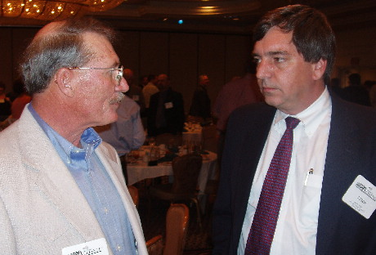
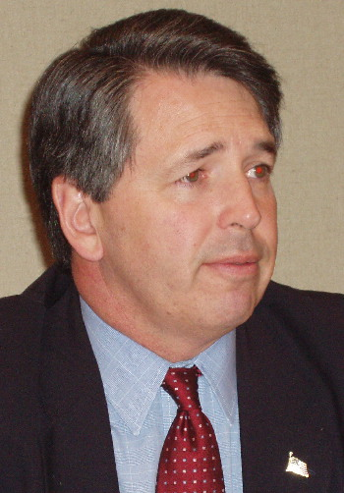
The large delegation attending the Family Farm Alliance’s 17th Annual Meeting in Las Vegas heard presentations by (from left) Commissioner of Reclamation John Keys (please see story on Page 6) and Deputy Commissioner Mark Limbaugh (former Alliance President). Right – Alliance President Pat O’Toole visits with luncheon speaker Jason Peltier, Deputy Assistant Interior Secretary For Water and Science.
O’Toole Says Conservation Can Only Do So Much

(Continued from Page 1)
“In an age where more dams are being torn down then being constructed – even though Western water demands are growing every year – many people shudder when the ‘D’ word is uttered,” said O’Toole.
He said projects listed in the Western Water Supply Enhancement Study database are supply enhancement projects such as canal lining and piping, and reconstruction of existing dams. Integrated resource plans are also listed.
“There are also some very feasible new surface storage projects,” said O’Toole. Benefits from these projects include providing certainty for rural family farms and ranches, additional flows and habitat for fish, and cleaner water.”
The initiative is not is a list of supply enhancement projects recommended by the Alliance for implementation. Instead, it is intended to catalyze discussions on the need to improve Western water supplies, to encourage other Westerners to submit additional ideas to the Alliance, and to form the basis for further evaluation as to why these projects have never been implemented.
O’Toole ALSO told the panel that water conservation is often viewed as a solution to water supply needs.
“While conservation is surely a tool that can assist in overcoming water supply problems, it cannot be viewed as the single answer to water shortages,” O’Toole said. “Mandated or one size fits all conservation programs are doomed to failure in light of the drastically different circumstances of water users across the West.”
He said there has been massive investment in conservation and water management technology over many parts of the West.
“On the other hand, relatively little progress has been made on the “supply management” end of things,” said O’Toole. “While development has occurred on conjunctive management and groundwater banking projects, development of new surface storage projects have virtually ground to a halt in the past 30 years, especially if any sort of federal nexus exists for proposed projects.”
O’Toole said water conservation cannot be stretched indefinitely without reducing acreage in production.
“At some point, the growing water demands of the West – coupled with the omnipresent possibility of drought – must be met,” O’Toole said. “The water needed to meet these demands will either come from developing new water
supplies, or it will be taken from agriculture. “
O’Toole said aging infrastructure must be modernized and opportunities to enhance supplies must be facilitated “before the West’s growing demand outstrips available water supplies, which is already happening in some areas.” He said strict conservation, frequently employed during droughts, “cannot be the sole answer.”
these factors and many others, he said, add up to preserving water supply certainty.
“The goal of certainty is perhaps the most important aspect of Western water policy,” said O’Toole.
“Without certainty, those investments in water supply facilities will be less efficient, and otherwise beneficial investments will not be made because of the fear that water supplies will be taken away. The loss of supplies will have a significant, if not devastating, economic effect on those who lose the benefit of their investment.”
O’Toole asked for federal support of “new efforts to enhance water supplies and encouraging state and local interests to take the lead in the formulation of those efforts.”

