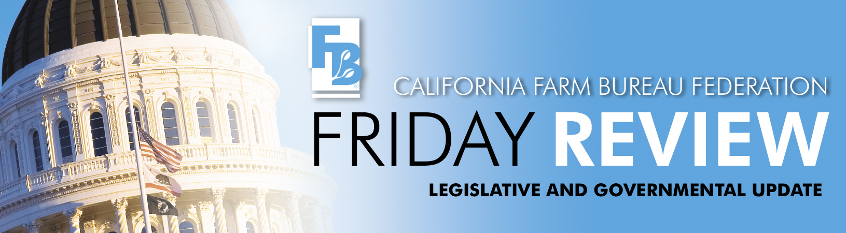

June 26, 2009

The popular expression “been there, done that” seems particularly appropriate this week in describing the Legislature’s activity to resolve the ongoing State Budget crisis. With the backdrop of the State Controller once again announcing that the state will not be able to pay all of its bills as of July 1st, there were several budget package “drills” on the floors of both houses. Democrats advocated a short-term fix to defer payments that are due next week to state schools and universities as well as cities and counties for road repair, while Republicans in the Senate stood firm on the need for a complete budget package.

Controller John Chiang reminded the legislature that due to strict constitutional mandates regarding payments to schools, bondholders, and state employees, he would be forced to issue IOUs for other bills coming due in the new fiscal year. The long-term negative impact on the state’s credit rating and the added cost of future borrowing notwithstanding, the stalemate continued.

While the Assembly acted in a bipartisan manner to head off the cash crunch, the Senate Republicans balked at approving three bills (SB 64, SB 74 and SB 80, all authored by the Senate Committee on Budget and Fiscal Review) that would have supposedly eliminated the need for IOUs through August. Governor Schwarzenegger also voiced his opposition to what he called a piecemeal approach to dealing with the entire deficit. Just how big a piece would be fixed is open to interpretation. Senate President Pro Tem Darrell Steinberg (D-Sacramento) estimated that if Republicans had approved the $11 billion in cuts offered earlier in the week, the three bills would solve two-thirds of the budget shortfall. Republicans in both houses rejected the cuts package a day earlier on the grounds that the cuts didn't go deep enough.

The politics of playing chicken with millions of dollars of future interest payments at stake was deemed “reckless” by Senator Steinberg, but the governor said he would veto the three-bill package designed to reduce the cash flow problem. By keeping the pressure on, the governor’s position is clearly stronger as they move into the next phase of negotiations.

To complicate matters for the Democrats in their quest for a State Budget solution, Assembly Member Juan Arambula (I-Fresno) bolted from the party and became an Independent just one day before a crucial floor vote on $11 billion in budget cuts. Arambula represents parts of Fresno and Tulare counties and has been a strong supporter of the Williamson Act subventions. He did not vote for the budget proposal by the Democratic leadership that contained a one-year suspension of the Williamson Act subventions. Arambula is not eligible to seek reelection to his current seat in 2010 due to term limits.

The Assembly Public Safety Committee passed SB 135, Dean Florez (D-Shafter) out of committee on a 4-1 vote. Assembly Member Arambula (I – Fresno), Chair of the Committee, abstained from voting on the bill. This bill would ban the practice of docking the tails of cattle. This bill is sponsored by the Humane Society of the United States and Wayne Pacelle, HSUS President, traveled to California to testify on the bill. CFBF was forced to oppose the bill unless amendments are taken that would allow cattle owners to dock tails in emergency situations. After negotiating with Senator Florez in the hallway during the committee hearing, he accepted our amendments. However, he added a provision that requires anyone who docks a tail in an emergency to report that action to the California Department of Food and Agriculture. The bill now moves to the Assembly Agriculture Committee, where Farm Bureau is working to obtain further amendments to delete the reporting requirement from the bill.

AB 1288, Paul Fong (D-Mountain View), passed the Senate Labor and Industrial Relations Committee on June 25. This bill would prohibit counties, cities or other local governmental units from requiring use of the seriously flawed federal E-Verify program as a condition of obtaining a contract or business license or settling any claim of unlawful activity. Broad coalitions of labor and employer groups, including CFBF, support AB 1288, which now moves to the Senate for floor consideration.

