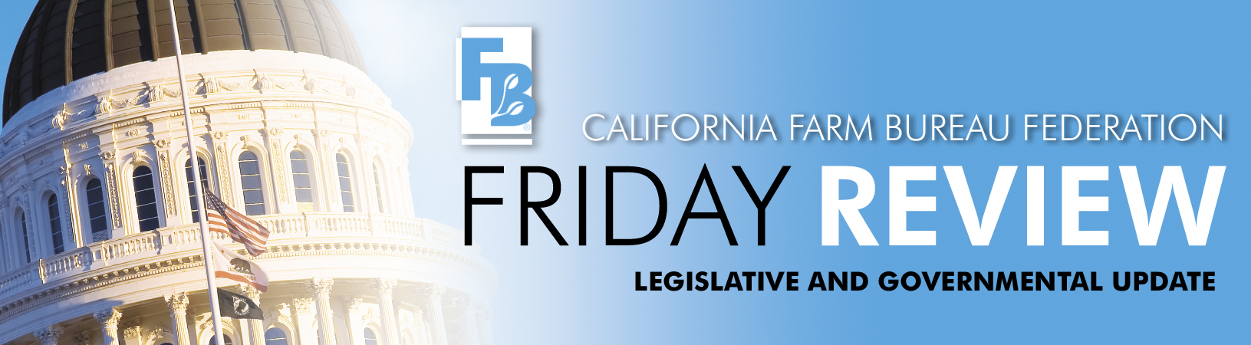
March 6, 2009

A bill that would allow federally recognized Indian tribes to more easily cancel Williamson Act contracts on land has been re-introduced by Senator Dean Florez (D-Bakersfield). The bill, SB 170, is identical to a bill that Farm Bureau opposed last year by Assemblymember Tony Mendoza (D-Artesia). The Chumash Tribe in Santa Ynez (Santa Barbara County) is sponsoring the bill that is ostensibly intended to allow tribes to build cultural centers, housing or infrastructure projects on contracted land.

Farm Bureau has yet to take a position on SB 170 but did oppose the previous version of the bill because it would open the door to the widespread loss of agricultural land as cash-rich tribes expand their real estate holdings without regard for the land’s agricultural preserve status. California and 54 of its counties have made significant public trust investments in the conservation of agricultural land through their participation in the Williamson Act contracts. Farm Bureau continues to fight hard to protect the integrity of Williamson Act contracts because we firmly believe in the sanctity of agricultural preserves and Williamson Act contracts. SB 170 will be heard in the Senate Local Government Committee sometime after March 17th.

A measure to override local zoning in order to facilitate the construction of farmworker housing has been introduced by Assembly Member Anna Caballero (D-Salinas). AB 494 would expand the provisions of a controversial 1999 law that allows up to 5 acres of Williamson Act land to be sold or leased to a non-profit, a city, a county, a housing authority, or a state agency for the development of farmworker housing.

Current law requires the contracted land be in a city or within a sphere of influence of a city or unincorporated territory and it has to be contiguous to a property that is zoned commercial, industrial, or residential and developed for commercial, industrial or residential uses. AB 494 would increase the size of the parcel sold or leased to 10 acres in order to accommodate 150 to 200 units, eliminate the contiguity requirement, if the housing is located on a water and sewer line, and would apply to all zoning designations in addition to agricultural preserves.

California's farmers are going to need housing for their employees if they are ever going to be able to utilize any yet to be adopted guest worker program. The problem is how and where to provide that housing. Farm Bureau has not yet taken a position on AB 494 but two concerns immediately come to mind: how would the projects be buffered and why would we want to isolate farmworkers away from city services and conveniences by eliminating the contiguity requirement. Also, transportation to and from the isolated housing developments could also be an issue without vanpools or other public transit.

Another Williamson Act proposal, AB 512, by Mariko Yamada (D-Davis), would make a statutory presumption that horse breeding and training facilities are a compatible use unless a county board of supervisors holds a public hearing and determines to the contrary. AB 512 is attempting to address a festering problem created by an interpretation by the Department of Conservation that the raising of this particular type of livestock does not qualify as an agricultural use because it is not produced for food or fiber. Farm Bureau has not yet taken a position on this bill, but we look forward to working with the author to address this issue.

A number of bills of interest to farm employers were submitted just prior to the deadline for bill introduction, including:

SB 789 by Darrell Steinberg (D-Sacramento) is the latest iteration of “card check” amendments to the Agricultural Labor Relations Act. Unlike last year’s vetoed “card check” bill, which would have created a complex and unsupervised process of “absentee balloting” for ALRA-sanctioned union elections, SB 789 simply allows a union seeking recognition under the ALRA to submit cards signed by a majority of the bargaining unit. Like last year’s “card check” bill, SB 789, would remove an agricultural worker’s right to a secret ballot vote on union representation as provided for under current law.

SB 287 by Ron Calderon (D-Montebello) would clarify that employers need only ensure that an employee has the opportunity to take legally mandated meal and rest breaks, rather than requiring the employer to ensure that the employee actually takes those breaks.

AB 849 by Sandre Swanson (D-Oakland) expands state-mandated Family and Medical leave by allowing workers to take family leave to care for adult children, in-laws, grandparents, siblings, grandchildren or domestic partners.

AB 854 by Juan Arambula (D-Fresno) would require a Farm Labor Contractor (FLC) seeking renewal or reinstatement of an FLC license to state, under penalty of law, that he or she has satisfied all requirements involving unpaid wages as a result of a Labor Commissioner order, court order or settlement.

AB 1000 by Fiona Ma (D-San Francisco) is a re-introduction of paid sick leave legislation by Ma that died in Assembly Appropriations in 2008. AB 1000 would require employers to provide paid sick leave to employees who work for seven days or more at the rate for one hour for every 30 hours worked. The accrued leave could be used after 90 days of employment. The employer would be required to grant leave diagnosis, care or treatment of health conditions of the employee or the employee’s family member or for leave related to domestic violence or sexual assault.

Farm Bureau has not established a position on these bills at this time, but will continue to follow and review them as they develop.

There are now five water bond proposals for the purpose of financing water supply reliability and environmental restoration programs. In addition to the two proposals reported on last week, SB 301 by Dean Florez (D-Shafter) and SB 371 by Dave Cogdill (R-Fresno), Farm Bureau is also analyzing the following proposals and participating in their development and on-going negotiations. Farm Bureau’s position on these bills is pending during the continuing developments.

AB 1187 (Jared Huffman, D-Marin and Anna Caballero, D-Salinas), would authorize the issuance of $10.035 billion general obligation bonds to finance water supply reliability and water source protection programs.

SB 456 (Lois Wolk, D-Davis), would authorize the issuance of $9.805 billion general obligation bonds to finance water supply reliability and water source protection programs.

SB 735 (Darrell Steinberg, D-Sacramento), would authorize the issuance of $9.785 billion general obligation bonds to finance water supply reliability and water source protection programs.

Farm Bureau is continuing to advocate the need for new surface storage, area of origin water rights protections and the need for a continuous appropriation provision to insure the money is actually spent on a comprehensive package. A special election in May will allow Californians to vote on all of these water bond proposals.

AB 916, Dan Logue (R-Marysville) was introduced February 27 to require the State Water Resources Control Board to adopt recommended standards, not regulations, for the permitting and operation of onsite sewage treatment systems. AB 885 (Hannah-Beth Jackson, D-Santa Barbara), which was signed into law in 2000, required the State Water Resources Control Board to adopt “regulations” or “standards” for permitting and operation of onsite sewage treatment systems. The Board drafted proposed regulations and held public workshops, but in response to public comment the Board directed staff to redraft the regulations. The hearing, originally scheduled for February 9, was then postponed indefinitely.

Assemblyman Ted Gaines (R-Roseville) has introduced AB 268 to repeal the statute adopted in 2000. Assemblymembers Jim Nielsen (R-Gerber) and Dan Logue (R-Marysville) are principal co-authors of AB 268. Farm Bureau is also working on these legislative approaches to resolve the issues related to the initial proposed onsite sewage treatment systems regulations.

The Senate Committee on Natural Resources and Water will hold a hearing on Tuesday, March 10th on the state’s water rights laws. Deputy Attorney General Cliff Lee will give the committee an overview of the water rights statutes. The committee will also hear from Department of Water Resources and State Water Resources Control Board officials on how water rights are managed in California. Officials from the Legislative Analyst’s Office, UC Berkeley and the American Bar Association will also present issues and perspectives.

