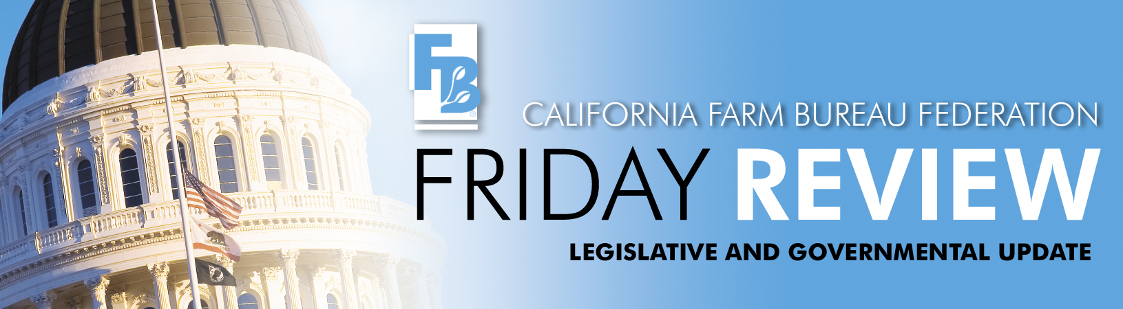

As California continues toward the greatest fiscal train wreck in its 158-year history, legislative leaders and the governor continue to spar over the right mix of new taxes, budget cuts, and economic stimulus that might avert the disaster. In an equally unprecedented maneuver, the Democrats proposed and passed an ingenious, albeit very likely unconstitutional, package of bills to allow the state to raise nearly $10 billion in new taxes by a majority vote of the Legislature.

Declaring that desperate times don't call for desperate measures and that desperate times call for “creative thinking,” the Democrats’ talking points on the tax increase package reminded everyone that they are the majority party and are responsible for governing the state and that means finding solutions to our budget crisis. Unfortunately, or fortunately depending on your perspective, there is this 30 year old provision in Article XIIIA, Section 3, that reads:

From and after the effective date of this article, any changes in state taxes enacted for the purpose of increasing revenues collected pursuant thereto whether by increased rates or changes in methods of computation must be imposed by an Act passed by not less than two-thirds of all members elected to each of the two houses of the Legislature, except that no new ad valorem taxes on real property, or sales or transaction taxes on the sales of real property may be imposed.

Backed by a legal opinion by their Legislative Counsel that few believed passed the smell test, the Democrats’ package included the following (Note: all measures were authored by the chairs of the Assembly and Senate budget committees, Assemblymember Noreen Evans (D-Santa Rosa) and Senator Denise Ducheny (D-San Diego):

- AB/SB 2x makes the following changes to current tax laws, which would be “revenue neutral,” and voilá a majority vote bill in the mind of the Democrats’ attorney:

Eliminates the current 18 cent per gallon excise tax on gasoline and diesel fuel
Eliminates the current sales tax on gasoline (currently about 8 cents per gallon)
Increases the state sales tax by ½ percent (permanent) - $2.3 billion annually

Creates a new and permanent 2½ percent surcharge on personal income taxes owed for all brackets - $1.5 billion annually.

Creates a new and permanent 9.9% oil severance tax on oil produced in California - $845 million annually.

- AB/SB 9x adjusts a complex revenue sharing arrangement between state and local governments, known as the ‘triple-flip.” The triple flip was a convoluted plan to repay the Economic Recovery Bonds.

Eliminates the ¼-cent temporary reduction of the local sales tax so that results in more property tax revenue going to schools, which in turn saves the General Fund approximately $95 million in the current year and $1.3 billion in the budget year.

- AB/SB 11x creates the following new gas and diesel “fees:”

A new and permanent 39-cent per gallon charge on gasoline with a CPI adjustment
A new and permanent 31-cent per gallon charge on diesel with a CPI adjustment
These raise at least $2.4 billion more than the current fuel taxes

- AB/SB 12x requires the withholding and payment to the state of 3% of amounts paid to independent contractors (such as real estate brokers, independent truckers, consultants, and others for whom the taxpayer would be required to issue a 1099). This is projected to bring in $2 billion annually in “new” revenue in 2009-10. In reality is it another accounting gimmick to speed collection of taxes due.

On the spending side, the Democrats’ cut package is the same as our November 25th proposal and based primarily on the governor’s lame duck special session proposal. About half of the cuts come from K-14 and higher education. The amount cut is similar to the amount in the Governor's proposal, but ultimately less harmful to the classroom (for example, cuts to deferred maintenance). The proposal also includes cuts to almost every other area of the budget, including health and human services, transportation, general government and criminal justice. Spending cut solutions total $7.3 billion. Additionally, the proposal has $1.5 billion in solutions that include small fund transfers, one-time solutions and fees.

The Williamson Act subventions, $34.7 million, were essentially suspended for the current budget year on a vote of 47 to 27 in the Assembly and 21 to 16 in the Senate. There were no Republican votes for the cut and the following members abstained: Senators Wiggins and Wyland and Assemblymembers Block, Buchanan, Cook, Fletcher, Huber, and V. Manuel Perez. The action contained in SB 7X (Ducheny) only repeals the statutory authorization for a continuing appropriation by the State Controller, thus the underlying formulas and requirements remain in the Government Code section 16140 et seq.

This may have been the biggest political drill yet in this ongoing budget crisis because Governor Schwarzenegger declared he would veto the entire package just moments after its adoption. Thus, it leaves everyone wondering whether or not all of the members knew the outcome before the votes. The veto would save the state thousands of dollars in legal fees because the end run around Proposition 13’s two-thirds vote requirement will be challenged, should the governor change his mind. Assemblymember Villines (R-Fresno) is committed to fighting for Williamson Act subventions in next year’s budget and the fight is not over yet for the current year either, should the governor make good on his veto threats. It should be noted that due to the state’s ongoing cash flow problems, a budget trailer bill adopted earlier this year does not allow the subventions to be paid until after April 20th. This fight to protect California’s most successful farmland protection program is far from over.

AB 25 authored by Danny Gilmore (R-Hanford) was introduced December 1. This bill will require the Department of Water Resources (DWR) to complete, by the earliest possible date, the necessary environmental impact reports for five surface water storage projects in order to expedite the construction of vitally needed surface water storage. This would require the DWR and the implementing agencies to carry out programs, projects, and activities necessary to implement the Bay-Delta Program. The projects identified are: raising Shasta Dam, enlarging Los Vaqueros, Sites Reservoir, Temperance Flat and a Delta Wetlands project.

