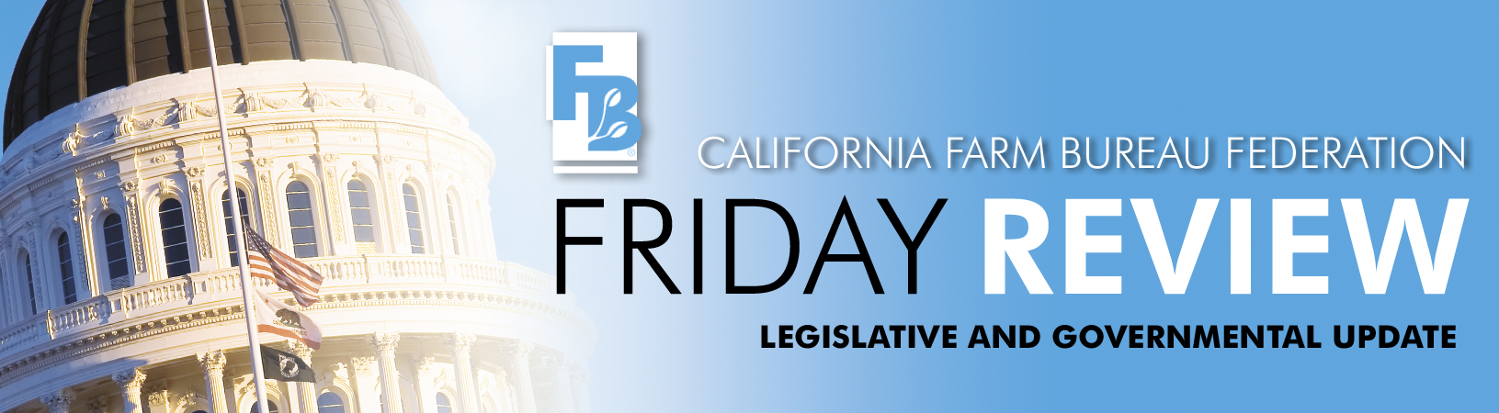SEPTEMBER 26, 2008

By now you all know we have a state budget, although many claim it is structured with a bit of creative accounting. There are no new taxes in the budget although some new tax penalties will result from some of the changes.

Most of the budget items important to agriculture remained intact and we won’t present the whole list of those again, but the governor did veto or blue pencil a few items agriculture had wanted funded in this year’s budget. He vetoed $3.6 million from the Department of Food and Agriculture budget including the following:

- $500,000 to fund the Red Imported Fire Ant program;
- $230,000 from the Pierce’s Disease Program;
- $1.7 million for the Diaprepes eradication program;
- $703,000 from programs related to Animal Health;
- $216,000 to Meat Inspection; and
- $200,000 related to Milk and Dairy Programs

Funding was provided for vehicle inspections at border stations. The Governor's Budget includes an increase of $7.5 million ($407,000 General Fund and $7.1 million Motor Vehicle Account Fund) and 117.5 positions to operate all Border Inspection Stations on a full time basis, inspecting all vehicles, commercial and private, entering California.

Additionally, budget trailer bill, AB 186 (Maze), extends the Central Valley Rural Crime
Prevention Program until July of 2012.

The governor is working through the 870 plus bills the legislature sent to him once the state budget was approved. Farm Bureau staff has been working to gain signatures on the following measures which we have previously reported on:

- AB 541 (Huffman, D-San Rafael) – Genetically Engineered Plants
- AB 844 (Berryhill, R-Modesto) and SB 691 (Calderon, D-Whittier) – Metal Theft
- AB 2168 (Jones, D-Sacramento) – Farm Stands – Sales of Value Added and Other Products
- AB 2881 (Wolk, D-Davis) – Right to Farm Disclosure

We are working for vetoes on the following measures also previously reported on:

- SB 974 (Lowenthal, D-Long Beach) – Cargo Container Taxes
- AB 2386 (Nunez, D- Los Angeles) – Employee Choice on Unionization (Card Check)

Next week we will have a complete report on what bills the governor signed into law and the measures he vetoed.

