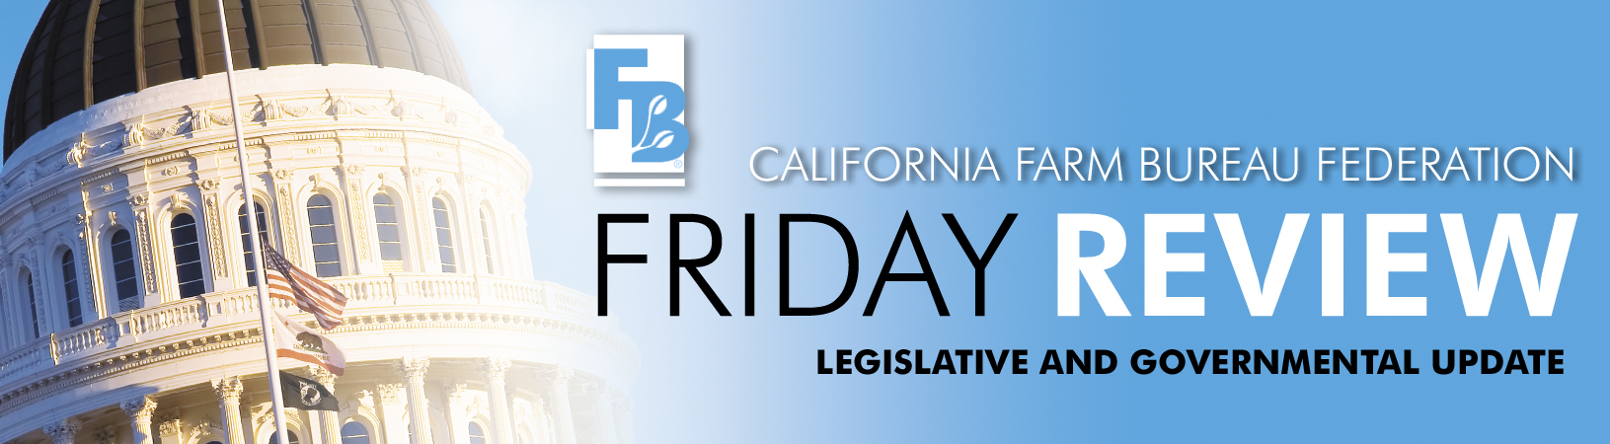

June 20, 2008
AB 844 (Berryhill, R-Modesto) & SB 691 (Calderon, D-Montebello) - Metal theft
AB 2168 (Jones, D-Sacramento) - allowing farmers to sell processed agricultural products at farm stands
AB 2763 (Laird, D-Santa Cruz) - establish and maintain a list of all potential invasive pests
AB 2881 - (Wolk, D-Davis) - requiring real estate disclosure of the state's right-to-farm law
AB 2921 - (Laird, D-Santa Cruz) - closing several loopholes in the material breach provisions of the Williamson Act
SB 1617 - (Kehoe, D-San Diego) - imposing a new $50 fire prevention fee on the owners of structures in the State Responsibilty Area
SB 1723 - (Maldonado, R-Santa Rosa) - requiring manufacturers to participate in the recycling programs insuring that more recycling programs are available and accessible to growers

The legislature moved one step closer to creating a solution to metal theft this week when Senator Calderon and Assembly Member Berryhill reached an agreement on the issue of preemption of local ordinances. Both AB 844 (Tom Berryhill, R-Modesto) and SB 691 (Ron Calderon, D-Montebello) will be amended to be identical bills. Each bill will require scrap metal recyclers to pay for scrap metal by check after a three day waiting period, take a picture of scrap metal being recycled, obtain current identification and a thumbprint from sellers, obtain a disclosure of the origin of the scrap metal, and report the information obtained to local law enforcement on a monthly basis. The bill also increases penalties against recyclers found in violation of the provisions and requires convicted metal thieves to pay restitution to victims of metal theft. CFBF is very appreciative of the two authors coming together on an agreement and is in strong support of both SB 691 and AB 844.

Also this week, SB 691 passed out of the Assembly Business and Professions Committee unanimously. This bill now moves to the Assembly Judiciary Committee. Despite the Senate Business, Professions, and Economic Development Committee’s assurances that it would vote on AB 844 this week, a vote did not occur. However, now that the two authors have agreed to one solution, the Committee will vote AB 844 on on June 23rd. Following the Business, Professions, and Economic Development Committee, the Senate Environmental Quality Committee and the Senate Public Safety Committee will most likely hear the bill. It is important for the Senate Public Safety Committee to hear from our members because the Committee has concerns with the thumbprint requirement in the bill. Look for a Farm Team Alert asking for members to come to Sacramento next week to testify in support of AB 844.

Farm Bureau’s sponsored bill, AB 2168 (Dave Jones, D-Sacramento), passed out of the Senate Agriculture Committee unanimously this week. This bill will allow farmers to sell processed agricultural products, such as jams, dried fruits, olive oil, etc. at their farm stands without being classified as Retail Food Facilities and therefore, subject to all of the requirements under the California Retail Food Code. The bill will now be heard by the Senate Health Committee, and is not expected to have trouble passing that committee as Senator Kuehl, Chair of the Senate Health Committee, voted for the bill as a member of the Agriculture Committee.

As an outshoot of the Light Brown Apple Moth outbreak, AB 2763 (John Laird, D-Santa Cruz) would require CDFA to do advance planning on how California will treat a potential pest or disease should it enter the state. CDFA would need to establish and maintain a list of all potential invasive pests and provide local governments and the governor with notice of any invasive pest found in the state and whether pesticides will be used. The Senate Agriculture Committee approved AB 2763 on a 5-0 vote. CFBF supports.

The Senate Agriculture Committee unanimously approved a measure that would require real estate disclosure of the state’s right-to-farm law. AB 2881 (Lois Wolk, D-Davis) was amended significantly prior to the hearing to address numerous concerns raised by the California Association of Realtors and First American Corporation, a company that performs the analyses to determine whether a disclosure is necessary. A compromise was reached at Farm Bureau’s urging that will ensure mandatory disclosure for all properties for sale within one mile of land designated as prime farmland, farmland of statewide importance, unique farmland, or farmland of local importance. There is now no opposition to AB 2881 and it will next be heard in the Senate Judiciary Committee on June 24th.

A bill to close several loopholes in the material breach provisions of the Williamson Act was approved by the Senate Local Government Committee. AB 2921 (John Laird, D-Santa Cruz) was amended in committee to address late opposition from the Audubon Society regarding the expansion of the easement exchange program. The bill will now have no effect on existing law relative to the easement exchange program whereby a landowner can purchase an agricultural conservation easement in lieu of paying the 12.5 percent cancellation penalty fee when the contract can be legally cancelled. The bill will also extend the December 31, 2009 sunset provisions regarding lot-line adjustments in the Williamson Act to December 2010. The measure also makes important but generally technical changes to the law relative to a material breach of contract. For example, a property owner found to have a potential material breach could not simply seek a cancellation of the contract. Local governments would also be required to hold a public hearing and make specific finding, based on substantial evidence on the record that a material does or does not exist whenever there is a disputed claim. AB 2921 was also double referred to the Senate Judiciary Committee where it will be heard on June 24th.

The bill that would impose a new $50 fire prevention fee on the owners of structures in the State Responsibility Area (SRA) sailed through two Assembly policy committees this week. Farm Bureau continued to oppose SB 1617 (Christine Kehoe, D-San Diego) based on the fact that the bill, as drafted, would impose a tax and not a fee. Thus, it should rightfully require a two-thirds vote of the Legislature. Without a stronger statutory commitment that fees raised within a given jurisdiction would actually be spent in that area for fire prevention, the bill imposes a tax. Farm Bureau also continued to voice concern regarding the flimsy definition of a “certificate of occupancy” that would trigger the $50 per structure fee. We believe that any final inspection could be interpreted as a “certificate of occupancy.” We are also opposed to spending the newly raised “fee” for the ongoing program of mapping the state’s fire severity zones. The bill was approve by both the Assembly Natural Resources Committee and the Assembly Local Government Committee on strict party-line votes, all Democrats voting “AYE” and all Republicans voting “NO.” SB 1617 will next be heard in the Assembly Appropriations Committee. Senator Kehoe has committed on numerous occasions to finding a way to address our remaining issues.

The California Department of Pesticide Regulation (CDPR) is sponsoring legislation that will require manufacturers that sell pesticide products in California to establish or participate in a pesticide container-recycling program and provide documentation to the CDPR certifying that this requirement has been met. Currently, growers must triple wash empty pesticide containers and contact their county agricultural commissioner to conduct an inspection to insure they have been cleaned properly. The recyclers that are available and certified to take the clean, empty containers are extremely limited throughout the state. Thus the ability for growers to take their containers to a recycler in a timely or efficient manner does not exist for the majority of California growers.

By requiring manufacturers to participate in the recycling programs, SB 1723 (Maldonado, R-Santa Maria) would help insure that more recycling programs would be available and accessible to growers. The Assembly Agriculture Committee approved SB 1723 on an 8-0 vote. CFBF supports.

