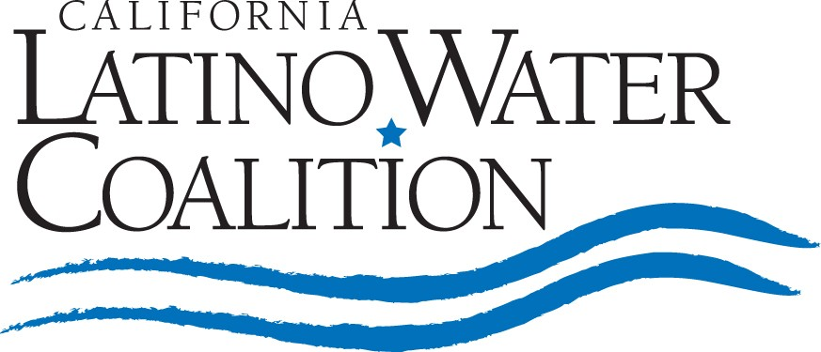
March 27, 2009

CALIFORNIA MARCH FOR WATER

In mid-April, the California Latino Water Coalition (CLWC) will stage a massive San Joaquin Valley march from the City of Mendota, California, to San Luis Reservoir, west of Los Banos. This event is to spotlight California’s water crisis – a growing emergency impacting increasingly larger segments of the California population and Latinos in particular. An expected 2,000 farmers, Latino farmworkers, business people, elected officials and civic leaders will march through a portion of the state that has been ravaged by the water crisis. The purpose is to raise awareness of an issue that is affecting nearly every California city and, for many of those in decision-making positions, has to be seen to be believed.

March Route
The multi-day march is scheduled to start in the City of Mendota, approximately 40 miles west of Fresno. It will conclude at San Luis Reservoir. Mendota is one of the towns hardest hit by drought with 40% unemployment, unrelenting poverty and a stark example of what would happen to other cities if water were to stop flowing from natural and/or man-made causes. Marchers will make their way though communities experiencing pronounced economic distress. Along the route there also will be other examples of the enormous impact of the water crisis – fallowed and barren land, stumped orchards and other dried out lakes, streams and water features.

As we march alongside the I-5 freeway, the California Aqueduct, and through valley communities, participants will carry signs calling for additional water. This 70-mile route will partially visible to hundreds of thousands of travelers. Tractors, produce trailers and semi-trucks with large signs will escort marchers and bring additional visible attention to the march.

News Announcements and Goals
Each day, marchers will start or end with a rally featuring announcements and news events meant to bring maximum awareness. The rallies and marching will be led by actor and CLWC Chair Paul Rodriguez who will be joined by other Latino entertainers, legislators and statewide leaders.

At strategically selected locations, marchers and march leaders will make several calls for action focusing on three goals to bring about a reliable water supply and improved water quality for all of California:

- First, to temporarily and immediately relieve severe Endangered Species Act standards that are preventing much needed pumping from the Delta to other regions of California.
- Second, to urge state legislators to agree on one comprehensive water plan to put before voters as a bond measure in the next election.
- Third, to call for public funds for those facing remarkable hardship and federal stimulus dollars to address shovel-ready water infrastructure projects.
California Governor Arnold Schwarzenegger to Address Marchers
On the final day, California Governor Arnold Schwarzenegger has been invited to welcome marchers at San Luis Reservoir to offer encouragement to those who have worked so hard to bring attention to the state’s water crisis. With the backdrop of record low, washtub-ringed San Luis Reservoir, a rally will be held to call on federal authorities and state legislators to work overtime to address this year’s critically low water supply and future anticipated shortages in the state’s water system.

Our Need for Funding
Clearly, this is a major undertaking for the CLWC. As a recently founded not-for-profit, we are severely limited financially. That is why we are calling on everyone with a vested interest in finding solutions to our water needs to support this effort. Our initial budget for this whole effort is projected to be roughly $60,000.

Funds will be used to manage logistics and support marchers including many unemployed farm workers. Specifically, funds will be used for:

- Shuttles for marchers.
- Meals and water.
- First aid provisions.
- Signs and signage.
- Security and traffic control.

We have plans in place to bring state-level and national media attention to the plight being faced by Latinos and millions of other Californians in the absence of a stable and sufficient water supply. We are asking that you help us with this important effort by pledging funds.

In addition to monetary support we also need any and all in-the-field manpower backing to aid and assist with media relations, marcher needs and word-of-mouth marketing, etc.

This is our chance to be heard and could be the best opportunity we have for years to finally address our woefully inadequate statewide water resources. I urge you to consider a financial contribution and get personally involved in the march.

Best regards,



Paul Rodriguez
Actor/Comedian
California Latino Water Coalition Chair

YES! I WANT TO SUPPORT THE CLWC MARCH!!

◻ $5,000 or More (Please specify): ______________ ◻ $2,500: _______________
◻ $1,000: _______________ ◻ Other: _______________

Name:_____________________________ Company: ______________________________

Mailing Address: ___________________________________________________________
___________________________________________________________

E-Mail Address: ___________________________________________________________
Telephone: (______) ____________________ Fax: (______) _______________________

Please send your contributions to the
California Latino Water Coalition

1415 L Street, Suite 400, Sacramento, CA 95814
For more information, please contact
Piedad Ayala: (559) 284-0168
Steve Lowe: (559) 269-1994
Mario Santoyo: (559) 799-0701
Angie Vega (559) 488-3541

I can help by:

1. Participating or Providing Rally Participants or March Participants

2. Providing Food or Water

3. Providing Trucks, Tractors, or Trailers

4. Providing Transportation (Buses)

5. Media Outreach

6. Providing Funds or Raising Funds

7. Other : _________________________________________________________

