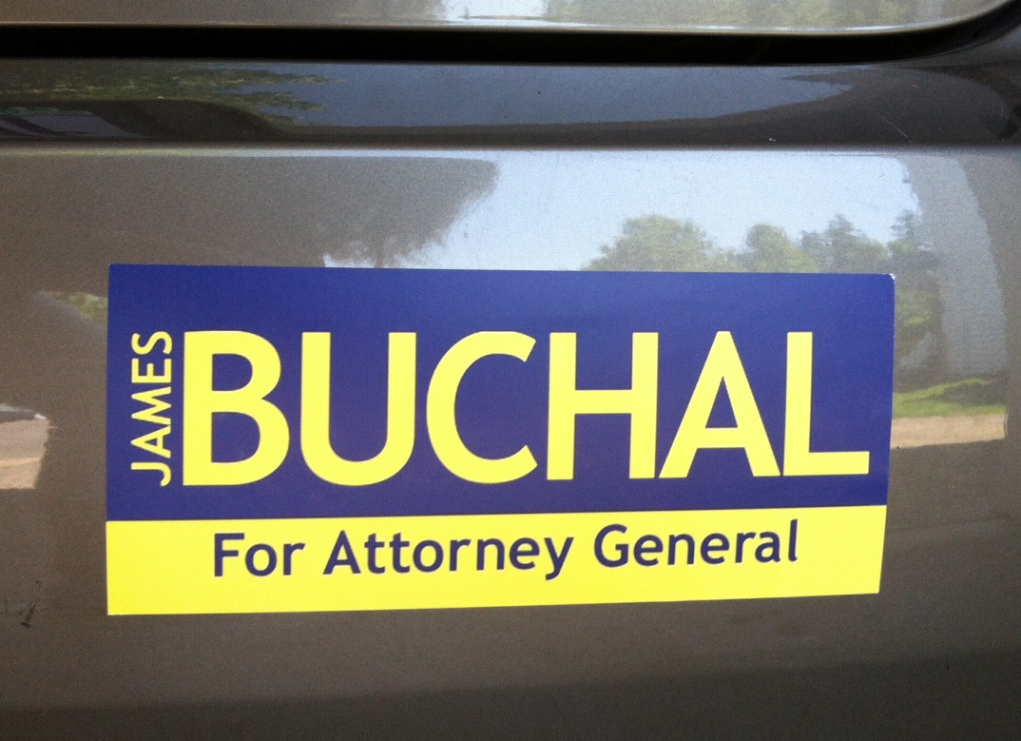
Oregon Attorney General
Candidate
James Buchal

Author of the book
“The Great Salmon Hoax”
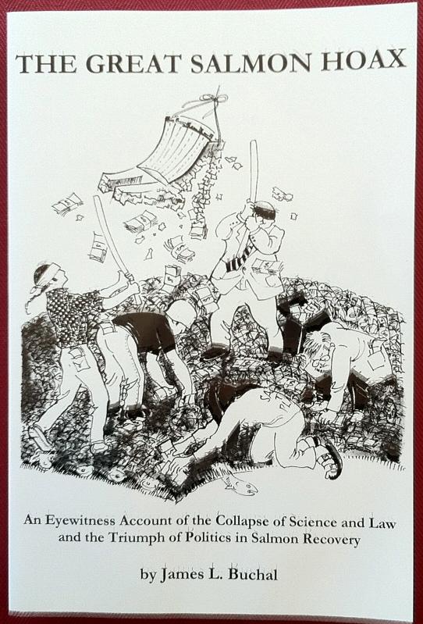

Would like to meet you at his fundraiser and book-signing event on:

Friday August 24, 2012

Medford

1pm
Jackson County GOP Headquarters
311 East Main Street
Medford, OR 97501

Grants Pass

5pm
James Buchal
Fundraising Reception for
GOP Nominee for Oregon Attorney General
James Buchal
111 SE 6th Street
Grants Pass, Oregon 97526

As an attorney, James Buchal has spent his career advocating on behalf of Oregonians against the state’s efforts to deprive his clients of their private property rights.

Supporters say:

“Buchal is like a breath of fresh air.”

“Buchal is the best speaker I have ever heard.”
“
Finally a candidate who says what needs to be said.”

James Buchal
for Attorney General of Oregon

We have got Government Cancer
Youtube video

Suggested donation $50+

