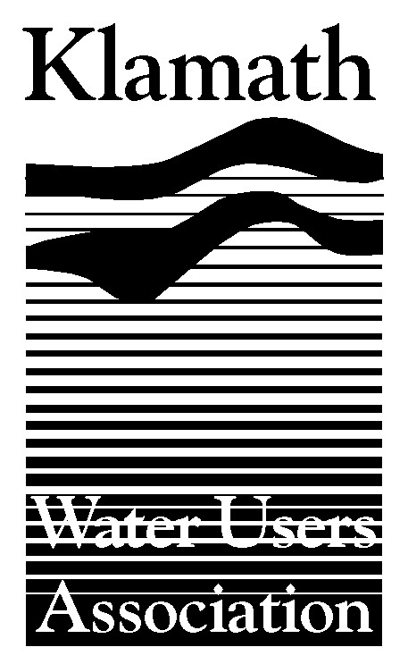
Klamath Water Users Association
2455 Patterson Street, Suite 3
Klamath Falls, Oregon 97603
(541)-883-6100 FAX (541)-883-8893
kwua@cvcwireless.net
www.kwua.org

National Academy of Sciences
Committee on Hydrology, Ecology and Fishes of the Klamath River Basin

Shilo Inn, Klamath Falls, OR
January 29, 2007

Testimony of:

Greg Addington,
Klamath Water Users Association

On behalf of KWUA, its member districts and their associated patrons, I want to thank the committee for holding this meeting here in Klamath Falls.

I also want to personally thank the chairman and staff of the NAS for working us back into the agenda. I can only imagine how chaotic it must be to organize these meetings. We had some miss communication that I think we cleared up, but I really want to say thank you for working with us.

Mr. Chair and members of the committee, I submitted some written comment at your last meeting in Yreka. At that time, I asked to reserve the right to submit additional information or to provide testimony. In Yreka we focused, primarily on the Hardy flow study, we now turn our attention to BOR’s Natural Flow Study. In just a minute I am going to turn this over to Mr. Marc VanCamp who is a principal engineer with MBK Engineers who helped us sift through the information and also had a role on the Bureau’s technical review committee.

KWUA has always believed that sound science is a critical need when making decisions related to Klamath. We are grateful to have this committee’s involvement, in essence having another set of eyes looking at these two products.

We continue to have concern and want to raise the issue of the processes that lead to these products.

We had technical people involved with review of both studies. Dr. Dave Vogel participated on behalf of KWUA on the Hardy Technical Team. In our opinion, the process was meaningless. It became a numbers game with the emphasis being less about discussing issues and alternative perspectives and more about rubber-stamping a product and an outcome. The process was so bad that it ultimately led to Dr. Vogel’s departure from the technical team.

Mr. VanCamp can speak more to the Natural Flow Study process and product. I would just say that parties including, but not limited to KWUA had concerns with the significant changes from various drafts to the final report. We were assured that those concerns would be addressed in a subsequent “technical memorandum”. We are here today, because we feel that was not the case. In particular there are two issues that we want to call your attention to and I will let Mr. VanCamp articulate.

Respectfully Submitted,

Greg Addington
Executive Director

