



UNITED STATES DEPARTMENT OF COMMERCE Economics and Statistics Administration
U.S. Census Bureau
Washin'gton, DC 20233-0001
OFFICE OF THE DIRECTOR

DEe 3 2007
Ms. Elaine D. Willman National Chair
Citizens Equal Rights Alliance P.O. Box 1280
Toppenish, W A 98948
Dear Ms. Willman:
This is in response to your letters of September 5, 2007, and November 5, 2007, to Secretary of Commerce Carlos M. Gutierrez and Mr. JOh11 J. Sullivan, General Counsel, U.S. Department of Commerce, regarding the Local Update of Census Addresses (LUCA) Program. Your letters express concerns about the U.S. Census Bureau's policy regarding addresses located within the boundaries of federally recognized American Indian reservations and/or off-reservation trust lands.
Our policy for the LUCA Program has been that we would provide addresses contained within the boundaries of federally recognized American Indian reservations and off-reservation trust lands only to the associated tribal government. This was in keeping with the unique government-to-government relationship between the federal government and federally recognized tribes.
Over the past several months, we carefully reviewed this policy and determined that this approach is not consistent with our statutory obligations. The Census Bureau is required by statute (Title 13, United States Code, Section 16) to provide its list of addresses for review to local units of general purpose government. The original plan would have limited this review. Accordingly, we will now be providing municipalities and tribal governments with all of the addresses under their jurisdiction.
If you have any further questions regarding LUCA, please have a member of your staff contact Mr. Robert A. LaMacchia, Chief of our Geography Division, at (301) 763-2131.

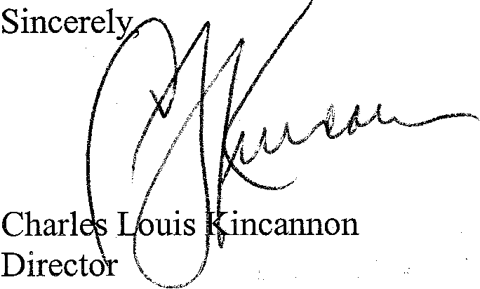
USCENSUSBUREAU

J..JeJping You Make Informed Decisions

www.census.goY

