JUL-11-07 01:37 PM HARRAH TOWN HALL

84::::243<3
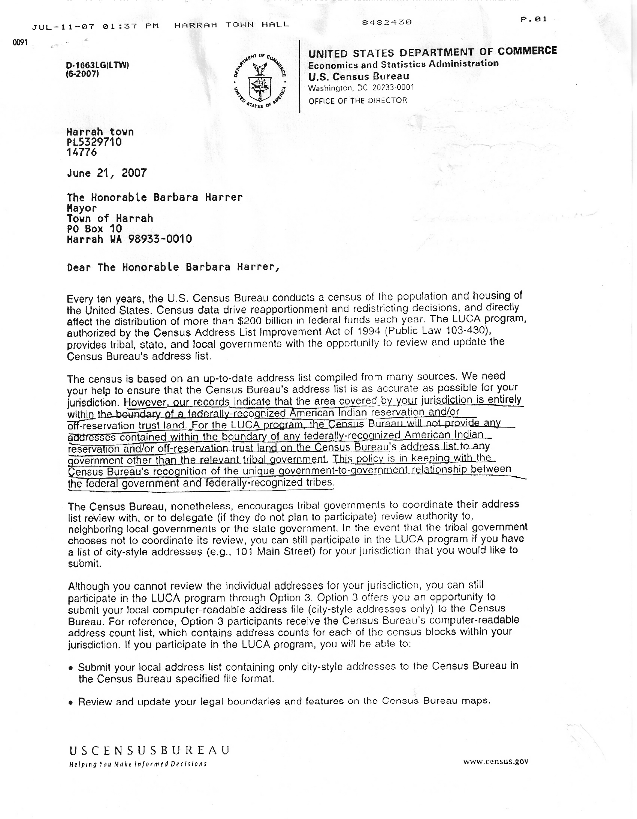
P.02

The enclosed 2010 Census Local Update of Census Addresses (LUGA) Program -- Loca.l Government Information Booklct, provides an overview of the LUCA program. The booklet also answers questions that may assist your government in deciding whether to participate in the program once you receive the invitation letter in August 2007.
Also enclosed is a Contact Information Update Form listing local contacts that we presently have on file for your jurisdiction. Please have a member of your staff review and correct the information printed for each contact person. Return the completed form to the Census Bureau in the enclosed pre-addressed, postage paid envelope or fax it to 206-381-6313 within 2 weeks of receipt of this letter. Thank you for taking the time to review and correct the Contact Information Update Form. Accurate contact names and addresses are essential if the Census Bureau is to convey timely information to your jurisdiction regarding opportunities to participate in Census Bureau programs.
Iif you have any questions regarding the LUCA program after reviewing the enclosed booklet, please contact your Census Bureau Regional Office by telephone at 1-866-511-LUCA (5822) or via e-mail at seatt le. geog I"aphy@census.gov.
Your Census Bureau Regional Office may have already, or soon will, invite you to ot1end 0. 2010 Census LUCA program promotional workshop. The promotional workshop introduces the 2010 Census LUCA program and provides background information on program goals, participation options, program materials, and security guidelines. In August 2007, the Census Bureau will send the LUCA program invitation letter and registration materials to you. Please use the time between now and August 2007 to decide on your jurisdiction's participation and begin any necessary preparations.
Sincerely,

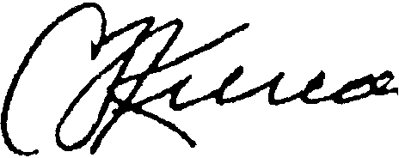
Charles Louis Kincannon Director
Enclosures
CC: Pat Horrell

O"66JLGILTW) (62007) July 30, 2007

Charles Louis Kincannon, Director
Economics and Statistics Administration
U. S. Census Bureau
United States Department of Commerce
Stop 7400
4600 Silver Hill Road
Washington, D.C. 20233-7400

Dear Mr. Kincannon,

Your letter of June 21, 2007 to the Town of Harrah (PL5329710) regarding the Local Update of Census Addresses (LUCA) Program finds me left with more questions than answers.

I call your attention specifically to the following statement within the June 21st transmittal, attached for your convenience:

“…our records indicate that the area covered by your jurisdiction is entirely within the boundary of a federally-recognized American Indian reservation and/or off-reservation trust land. For the LUCA program, the Census Bureau will not provide any addresses contained within the boundary of any federally-recognized American Indian reservation and/or off-reservation trust land on the Census Bureau’s address list to any government other than the relevant tribal government. This policy is in keeping within the Census Bureau’s recognition of the unique government-to-government relationship between the federal government and federally recognized tribes.” [Emphasis added]

Within the exterior boundaries of the Yakama Indian Reservation are three distinct and equally “relevant” municipal governments of the State of Washington (Harrah, Toppenish and Wapato). Yakima County is an additional relevant sub-division of a state government within the Yakama Indian reservation boundary. A perusal of your records will review that the demographics of all three of these communities are as follows:

Municipality | Hispanic | White | Native American
Harrah | 44.1% | 40.6% | 19.2%
Toppenish | 75.7% | 31.5% | 7.9%
Wapato | 76.2% | 25.5% | 9.3%
Source: American FactFinder, www.census.gov

As an anecdotal observation, it is likely that the 2010 Census data will evidence that Hispanic figures noted above for all three communities have increased since 2000, the Anglo population decreased, and the tribal government enrolled membership remained stable, or very slightly increased.

As Mayor of the Town of Harrah it is entirely unsettling to think that a federal agency charged with census statistics utilized for federal programs and funding allocations would erase or merge the census of separate (municipal) governments from record keeping of the United States Census, or that these municipalities, as suggested in your letter, would be required by our federal government to defer for census data collection and record-keeping needs to a separate tribal government that neither governs nor serves the respective municipalities. It is equally distressing to think that United States Census Bureau statistics for federally-recognized tribes would be so intentionally and erroneously inflated by adding population statistics of municipal lands over which federally recognized Indian tribes have neither governance, jurisdiction nor duty.

Similar scenarios of state municipalities located within the exterior boundaries of Indian reservation exist in Montana, Wisconsin, Wyoming and likely other states as well. These municipalities and county subdivisions of a state are “relevant” governments as designated by the sovereignty of the host State, particularly considering their Constitutional governing structure. They are in fact, more relevant and permanent than governments subject to the plenary power of Congress. If this is not the case, then the United States Constitution has been turned on its head when a federal agency can artificially shift state census figures into a column that inflates enrolled tribal populations, to the direct harm of a state and its citizenry.

The U.S. Census Bureau’s 2010 mission of accuracy under the LUCA and other programs would be better served by making clear distinctions between a tribal government’s actual census of enrolled members as, for purpose of tribal funding allocations; to do otherwise is an intentional data disparity of enormous fiscal consequences to American taxpayers, and specifically to states, counties and their respective municipalities.

I request a written assurance from the U. S. Census Bureau that my municipality is in fact, relevant to the federal government, and that the U.S. census data maintained for the Town of Harrah (and all towns similarly situated within the United States) be appropriately distinguished and separate from any census data of a separate (tribal) government that has no authority over citizens within the jurisdiction I serve.

Moving into August 2007 there is adequate time for the U.S. Census Bureau to make appropriate policy changes in the LUCA program that adjust what appears to be a substantial flaw in census data collection policy that must be accommodated without legal or fiscal harm to states and their municipalities.

Sincerely,

Barbara Harrer,
Mayor of the Town of Harrah
P.O. Box 10
Harrah, WA 98933-0010
Phone: 509-848-2432

Copies to:

Senator Patty Murray
Senator Maria Cantwell
Congressman Doc Hastings
Governor Christine Gregoire
Attorney General Rob McKenna
State Senator Jim Honeyford
State Representative Bruce Chandler
State Representative Dan Newhouse
Yakima County Commissioners
Mayor of the City of Toppenish
Mayor of the City of Wapato

